Supplementary Material

An open, fully-processed data resource for studying mood and sleep variability in the developing brain

Supplemental Tables
Supplementary Table 1. Ecological momentary assessment (EMA) items.
Activity | Assessment | Question | Conditional logic, if any | Response
Sleep | Morning | About how many hours did you actually sleep? |  | Not at all. (score: 0)  Less than 30 minutes (score: 1)  30 minutes (score: 2)  1 hour (score: 3)  ...  15.5 hours (score: 32)  16 hours (score: 33)  More than 16 hours (score: 34)
Sleep | Morning | What time did you go to bed last night? | if morning_sleep_quantity is not equal to "Not at all". | Clock-like time picker
Sleep | Morning | What time did you fall asleep? | if morning_sleep_quantity is not equal to "Not at all". | Clock-like time picker
Sleep | Morning | What time did you wake up this morning? | if morning_sleep_quantity is not equal to "Not at all". | Clock-like time picker
Sleep | Morning | What time did you get out of bed? | if morning_sleep_quantity is not equal to "Not at all". | Clock-like time picker
Sleep | Morning | How would you rate the quality of your sleep? | if morning_sleep_quantity is not equal to "Not at all". | Very poor to very good (1-7)
Sleep | Morning | Which (if any) of the following sleep problems did you have last night? | if morning_sleep_quantity is not equal to "Not at all". | Difficulty falling asleep (0,1), awakening too early (0,1), feeling unrefreshed or unrestored despite enough hours of sleep (0,1), nightmares (0,1), other sleep problem (0,1), None of the above (2)
Context | Morning, Mid- day, Afternoon, Evening | Where are you right now? |  | Inside (0), Outside (1)
Context | Morning, Mid- day, Afternoon, Evening | Are you: | If inside | In your home (1), in home of relative or friend (2), at work or in class (3), in a restaurant/bar or in a store (4), in a gym or fitness center (5), in a hospital or doctor’s office (6), other place inside (7)
Context | Morning, Mid- day, Afternoon, Evening | Are you: | If outside | In a public park or garden (0,1), in your yard or at home (0,1), in your neighborhood (0,1), at school (0,1), in a vehicle (car, bus...) (0,1), in other place outside (0,1)
Context | Morning, Mid- day, Afternoon, Evening | Who are you with right now? | "No one" is a none type option (may not select any other options when this is chosen) | No one (2), A family member (0,1), Your romantic partner (0,1), Friends (0,1), colleagues or classmates (0,1), Strangers (0,1), Healthcare provider (0,1), Pets (0,1)
Context | Morning, Mid- day, Afternoon, Evening | What are you doing right now? |  | Working or studying (0,1), Socializing in person (0,1), Using your phone (0,1), Watching TV/videos, playing video games, reading (0,1), Traveling or commuting (0,1), Household chores, shopping (0,1), Physical exercise (0,1), Eating/drinking (0, 1), Personal hygiene care (0,1), Medical procedure or treatment (0,1), Nothing, resting (0,1), Other activity (0,1)
Context: Screen and Social Media Use | Morning, Mid- day, Afternoon, Evening | Since the last assessment, how much time did you spend on a computer, tablet, or smartphone, or watching TV? | If yes to current activity or activity since the last assessment = “working or studying”, “using your phone" or "watching TV/videos/" playing video games" | I did not use a computer, tablet, phone or watch TV (0), Less than 1 hour (1), 1-2 hours (2), 2-3 hours (3), 3-4 hours (4) more than 4 hours
Mood Circumplex | Morning, Mid- day, Afternoon, Evening | How happy vs. sad do you feel right now? |  | Very cheerful/happy to Very sad/depressed/unhappy (1-7)
Mood Circumplex | Morning, Mid- day, Afternoon, Evening | How calm or relaxed vs. nervous/anxious do you feel right now? |  | Very relaxed/calm to Very nervous/anxious (1-7)
Mood Circumplex | Morning, Mid- day, Afternoon, Evening | How inactive vs. active do you feel right now? |  | Very inactive/quiet to Very active/aroused (1-7)
Mood Circumplex | Morning, Mid- day, Afternoon, Evening | How tired vs. energetic do you feel right now? |  | Very tired/sluggish to Very energetic/lively (1-7)
Mood Circumplex: Negative Thoughts | Morning, Mid- day, Afternoon, Evening | To what extent are you having positive thoughts or thinking about nice experiences? |  | No positive thoughts at all to Many positive thoughts (1-7)
Mood Circumplex: Negative Thoughts | Morning, Mid- day, Afternoon, Evening | To what extent are you having negative thoughts or thinking about unpleasant experiences? |  | No negative thoughts at all to Many negative thoughts (1-7)
Life Events | Morning, Mid- day, Afternoon, Evening | Here we want to know what actually happened in your life since the last assessment. Since the last assessment, what event -good or bad- affected you the most? |  | Please describe briefly (subject verbatim text input)
Life Events | Morning, Mid- day, Afternoon, Evening | Was this event generally positive or negative? |  | Extremely positive =1.... 4=neutral....7 =Extremely negative
Life Events | Morning, Mid- day, Afternoon, Evening | Which category best describes the area of your life in which the event occurred? |  | Social interactions in-person (1), Social interactions online/on the phone (2), Accomplishment/getting things done (3), Health event/medical care (4), Learning about or witnessing something upsetting or something heartwarming (5), Other (6)
Life Events | Morning, Mid- day, Afternoon, Evening | To what degree was this event stressful for you? |  | Not at all stressful to Extremely stressful (1-7)
Physical Activity | Morning, Mid- day, Afternoon, Evening | Please select the level of activities that you have done since the last assessment or since you woke up if this is your first assessment of the day: |  | Vigorous activities (e.g., running, fast cycling, heavy lifting or digging) (0,1), Moderate activities (e.g., bicycling, carrying light loads) (0,1), Light activities (e.g., walking, climbing stairs, routine household chores) (0,1), Sedentary Activities (e.g., Napping, resting, or sitting) (0,1)
Physical Activity | Morning, Mid- day, Afternoon, Evening | Since the last assessment, how many minutes did you do vigorous activities including intensive sports or exercise (such as running or fast cycling) or intensive physical work (such as heavy lifting or digging)? | if since_physical_activity includes vigorous | About 5 minutes or less, About 10 minutes, About 20 minutes, About 30 minutes, About 40 minutes, About 50 minutes, More than 1 hour
Physical Activity | Morning, Mid- day, Afternoon, Evening | Since the last assessment, how many minutes did you do moderate activities (activities that make you breathe somewhat harder than usual such as playing tennis, bicycling, carrying light loads)? | if since_physical_activity includes moderate | About 5 minutes or less, About 10 minutes, About 20 minutes, About 30 minutes, About 40 minutes, About 50 minutes, More than 1 hour
Physical Activity | Morning, Mid- day, Afternoon, Evening | Since the last assessment, how many minutes did you do light activities (such as walking, climbing stairs, routine household chores)? | if since_physical_activity includes light | About 5 minutes or less, About 10 minutes, About 20 minutes, About 30 minutes, About 40 minutes, About 50 minutes, More than 1 hour
Food and Drink Intake | Morning, Mid- day, Afternoon, Evening | Since the last assessment, did you drink: |  | Water (0,1), Milk (0,1), A caffeinated beverage (like coffee, tea, soda...) (0,1), An alcoholic beverage (wine, beer, liquor...) (0,1), A beverage containing sugar like juice or caffeine free soda (0,1), Another type of drink (0,1), I did not drink (2)
Food and Drink Intake | Morning, Mid- day, Afternoon, Evening | How many 8-oz glasses of non- alcoholic fluids did you consume? | If since_had_drink = anything except "I did not drink" and "alcohol" | 1 8-oz Glass, 2 8-oz Glasses, 3 8-oz Glasses, 4 8-oz Glasses, 5 8-oz Glasses, 6 8-oz Glasses, 7 8-oz Glasses, 8 8-oz Glasses, 9 8-oz Glasses, 10 or More 8-oz Glasses
Food and Drink Intake | Morning, Mid- day, Afternoon, Evening | How many servings of alcohol did you consume? | If yes to alcoholic beverages | 1 Serving, 2 Servings, 3 Servings, 4 Servings, 5 Servings, 6 Servings, 7 Servings, 8 Servings, 9 Servings, 10 or More Servings
Food and Drink Intake | Morning, Mid- day, Afternoon, Evening | How many times have you eaten since the last assessment? |  | None: 0 (score: 0), 1: 1 (score: 1), 2: 2 (score: 2), 3: 3 (score: 3), 4: 4 (score: 4), 5: 5 (score: 5), 6: 6 (score: 6), 7: 7 (score: 7), 8: 8 (score: 8), 9: 9 (score: 9), 10: 10 (score: 10)
Food and Drink Intake | Morning, Mid- day, Afternoon, Evening | How much have you eaten since the last assessment? | If since_times_eat = 1 or more | Just a Snack: 1 (score: 1), Continuous Snacking: 2 (score: 2), A Small Meal: 3 (score: 3), A Regular/Full Meal: 4 (score: 4), A Large Meal: 5 (score: 5)
Pain | Morning, Mid- day, Afternoon, Evening | Are you in pain right now? |  | No pain to Extreme pain (1-7)
Pain | Morning, Mid- day, Afternoon, Evening | Where are you feeling pain? | If pain = 2 or more | Headache (0,1), Back/neck/shoulder (0,1), Arms/hands (0,1), Feet/legs (0,1) Stomach/bowel (0,1), Menstrual cramps (Females only) (0,1), Other Perineal (Females only) (0/1)
Pain | Morning, Mid- day, Afternoon, Evening | Have you experienced pain since the last assessment? |  | No/yes (0,1)
Pain | Morning, Mid- day, Afternoon, Evening | Where did you feel pain? | If yes: | Headache (0,1), Back/neck/shoulder (0,1), Arms/hands (0,1), Feet/legs (0,1) Stomach/bowel (0,1), Menstrual cramps (Females only) (0,1), Other Perineal (Females only) (0/1)
Pain | Morning, Mid- day, Afternoon, Evening | How intense was the pain? | If since_pain = yes | Very minor to Extremely intense pain (1-7)
Physical Health | Evening | How was your physical health today? |  | Very poor to Very good/excellent (1-7)
Physical Health | Evening | Did you have any of the following problems today? |  | Allergies (0,1), Asthma or breathing difficulties (0,1), Gastrointestinal, bowel or stomach problems (0,1), Muscle/joint pain (0,1), Heart racing or pounding (0,1) 'Feeling faint or dizzy' (0,1), 'Fever/Cold' (0,1), None of the above (2)
Physical Health | Evening | How much did these problems bother you today? | If any problem is endorsed | Not at all, Mildly, Moderately, Severely (1-4)

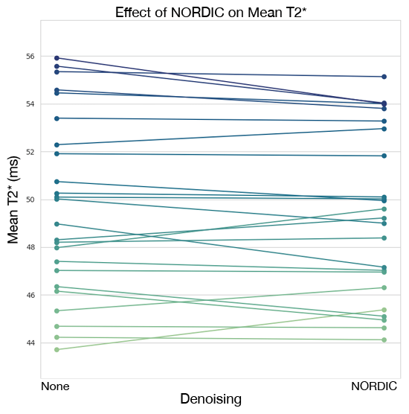
Supplemental Figures
Supplementary Figure 1. Effect of NORDIC denoising on mean T2*. The effect of NORDIC denoising on mean T2* found in preprocessed multi-echo fMRI is displayed. The inclusion and exclusion of NORDIC denoising did not dramatically change T2*.

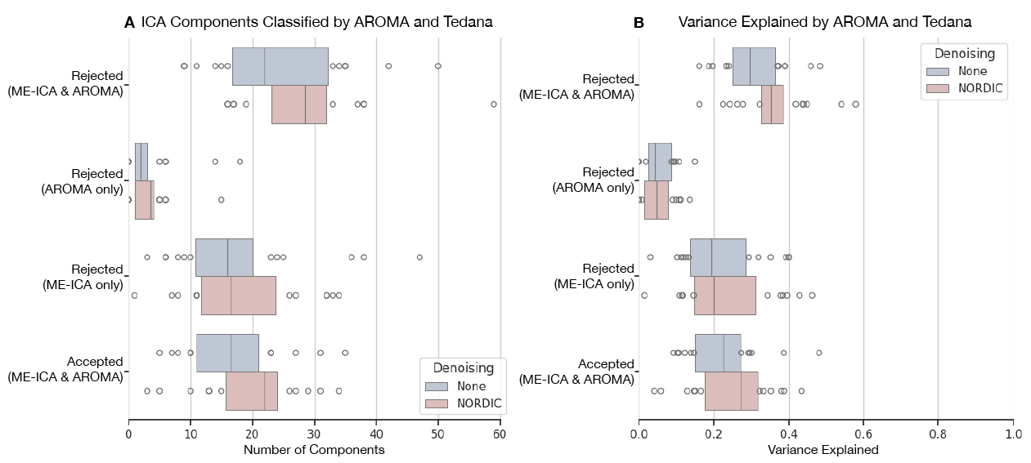
Supplementary Figure 2. Tedana and AROMA noise component classifications. Classification of noise components by tedana, which implements multi-echo ICA (ME-ICA), and AROMA are displayed. A) A plot of ICA components identified by tedana and AROMA shows that tedana identifies some noise components that AROMA does not. AROMA classifies very few components as noise that tedana does not identify as such. B) Comparing the amount of variance in the data attributed to these noise ICA components, tedana accounts for a larger proportion of variance as noise compared to AROMA. The blue and red bars show the effect of no NORDIC versus with NORDIC denoising, respectively.

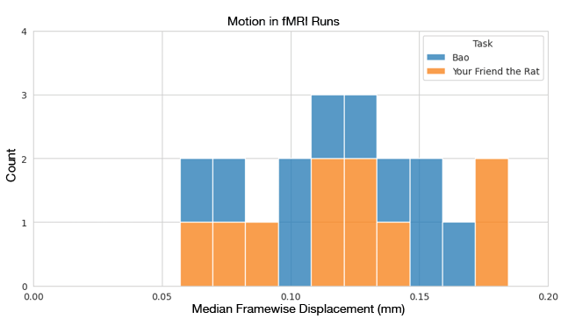
Supplementary Figure 3. Median framewise displacement (FD). A histogram of the median FD across all runs of the 10 initial subjects is displayed. The current study plans to exclude fMRI runs from the dataset if they have a median FD > 0.2 mm. Among the first 10 participants, none of the fMRI runs exceeded this threshold.

