Supplementary material
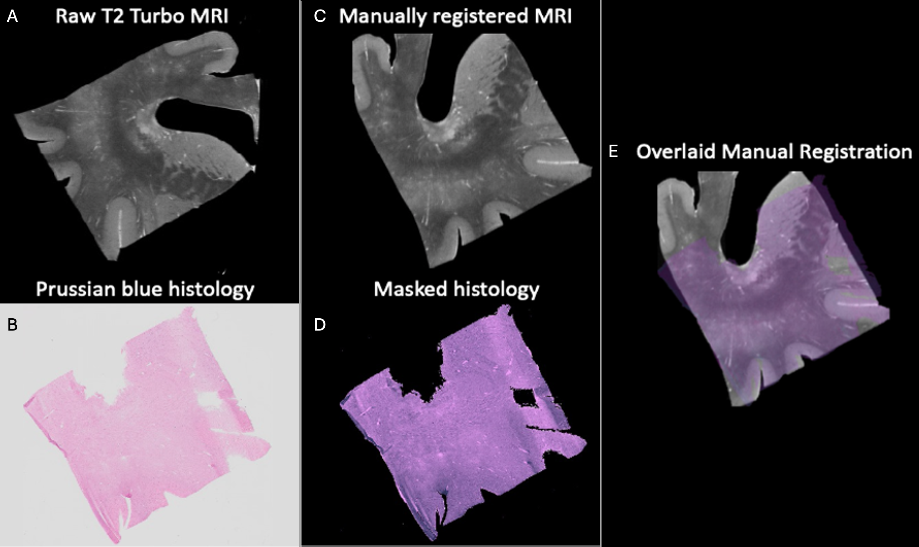
Supplemental Figure 1. Histology-MRI registration of a brain block fixed with SSS including periventricular white matter hyperintensities, internal capsule, cortex, subcortical white matter and head of the caudate nucleus. A) Raw T2-TurboRARE MRI sequence of the block; B) Prussian blue staining of the histologically processed block; C) T2-TurboRARE MRI manually co-registered to histology image; D) Extracted mask of the histology section; E) Co-localisation of histology and MRI modalities, showing the feasibility of registration of the two modalities in subcortical brain regions.

