Supplementary tables and figures

Table S1; Coefficient of variation of MRI metrics within-site and between-site calculated from an average of all relevant ROI measures.
MRI metric | Within site wCV% ( 95% CI: lower–upper) |  |  | Between site wCV%  (95% CI: lower–upper)
MRI metric | Site 1 | Site 2 | Site 3 | Between site wCV%  (95% CI: lower–upper)
Cortical thickness | 1.003 (0.701-1.306) | 1.146 (0.878-1.414) | 0.964(0.593-1.225) | 1.633(0.906-1.914)
Subcortical volume | 0.833(0.089-1.576) | 1.087(0.203-1.972) | 5.410(0.192-10.627) | 3.929(1.754-4.617)
FA | 0.662(0.3889-0.935) | 0.625(0.473-0.776) | 0.863(0.581-1.1457) | 3.268(2.833-4.201)
MD | 0.914(0.658-1.169) | 0.406(0.280-0.532) | 2.565(1.967-3.163) | 5.835(5.498-7.027)
tSNR | 7.386(3.719-11.053) | 9.666(6.716-12.615) | 5.715(3.396-8.035) | 6.725(1.914-4.015)
CBF | 5.579(1.327-9.832) | 5.033(0.854-9.213) |  | 13.010(8.761-20.459)
Majority of wCV% values are below the threshold of 10% (38). *pcASL data not available for Site 3.

Table S2; Comparison of key diffusion-timing and readout parameters across Siemens and Philips systems.
Parameter | Siemens Prisma | Philips Ingenia
Gradient amplitude (mT/m) | 80 | 45
TE/TR(ms) | 92/3600 | 97/6369
Multi Band factor | 3 | 2
In-plane acceleration | None (No GRAPPA) | SENSE=1.5
Pixel bandwidth (Hz/pixel) | 1785 | 1890
Dwell time (s) | 2.5 × 10⁻⁶ | ~5.3 × 10⁻⁴
Effective echo spacing (ms) | 0.66 | ~0.9
Estimated Δ (ms)* | 46 | 48.5
Estimated δ (ms)* | 26 | 18
Effective diffusion time (Δ − δ/3) (ms) | 37 | 42.5
* Note: Approximate diffusion-timing and readout parameters were derived from vendor exports and the Stejskal–Tanner relationship. Philips values are estimated where not explicitly available in the exam card metadata. The Siemens Prisma sequence used a monopolar diffusion-encoding scheme (CMRR implementation), whereas the Philips Ingenia employed a vendor-specific DTI-EPI sequence.

Table S3; Sequence-specific acquisition parameters and estimated FWHM across sites.
 | Sequence |  | Site | Session | MB factor | In plane acceleration | EES (s) | TRT (s) | FWHM (mm)
 | DWI |  | 1 | 1 | 2 | SENSE; 1.5 | 6.69E-04 | 7.42E-02 | 6.77
 |  |  |  | 2 |  |  |  |  | 6.85
 |  |  | 2 | 1 | 3 | None | 6.60E-04 | 7.33E-02 | 12.51
 |  |  |  | 2 |  |  |  |  | 13.13
 |  |  | 3 | 1 | 3 | None | 6.70E-04 | 6.90E-02 | 8.53
 |  |  |  | 2 |  |  |  |  | 11.01
 | fMRI |  | 1 | 1 | 2 | SENSE; 2 | 3.67E-04 | 3.48E-02 | 6.69
 |  |  |  | 2 |  |  |  |  | 6.67
 |  |  | 2 | 1 | 4 | None | 6.00E-04 | 5.70E-02 | 31.35
 |  |  |  | 2 |  |  |  |  | 30.08
 |  |  | 3 | 1 | 4 |  | 6.00E-04 | 5.70E-02 | 29.36
 |  |  |  | 2 |  |  |  |  | 28.85
 | pCASL |  | 1 | 1 | None | None | 6.02E-04 | 3.79E-02 | 9.76
 |  |  |  | 2 |  |  |  |  | 9.21
 |  |  | 2 | 1 | 1 | None | 5.80E-04 | 3.65E-02 | 38.15
 |  |  |  | 2 |  |  |  |  | 38.12
 | Note: MB = multiband acceleration factor; EES = effective echo spacing; TRT = total readout time; FWHM = full width at half maximum, representing the apparent spatial point-spread function estimated from residual images using AFNI 3dFWHMx with the autocorrelation function enabled

Table S4; Head motion estimates derived from DWI data across all sites and sessions.
 | Sequence | Site | Session | Mean RMS (mm) | RMS/min | Restricted RMS (mm) | Restricted RMS/min | Translation (mm) | Mean Rotation (× 10⁻³ °)
 | Sequence | Site | Session | mean ± SD |  | mean ± SD |  | mean ± SD | mean ± SD
 | DWI | 1 | 1 | 0.79±0.13 | 0.06 | 0.22±0.13 | 0.02 | 0.26±0.14 | 7.18 ± 4.69
 |  |  | 2 | 1.21±0.81 | 0.09 | 0.36±0.20 | 0.03 | 0.55±0.41 | 2.49 ± 1.14
 |  | 2 | 1 | 0.49±0.26 | 0.08 | 0.13±0.06 | 0.02 | 0.11±0.04 | 5.14 ± 3.08
 |  |  | 2 | 0.43±0.21 | 0.07 | 0.13±0.07 | 0.02 | 0.20±0.10 | 2.62 ± 1.55
 |  | 3 | 1 | 0.33±0.13 | 0.05 | 0.16±0.05 | 0.02 | 0.16±0.07 | 1.45 ± 0.62
 |  |  | 2 | 0.31±0.11 | 0.05 | 0.14±0.07 | 0.02 | 0.08±0.03 | 2.64 ± 1.04
 | Note: Mean root-mean-square (RMS), restricted RMS, translation, and rotation parameters were derived from eddy outputs for each DWI acquisition to quantify inter-volume motion. Values are reported as mean ± SD per site and session. Overall motion remained low across all sessions.

Table S5; Head motion estimates for fMRI and pCASL acquisitions across sites and sessions.

 | Sequence | Site | Session | FD (mm)  (Median ±SD) | RMS (mm)  (Median ±SD)
 | fMRI | 1 | 1 | 0.10±0.05 | 0.30±0.17
 |  |  | 2 | 0.09±0.05 | 0.18±0.08
 |  | 2 | 1 | 0.08±0.05 | 0.44±0.20
 |  |  | 2 | 0.04±0.02 | 0.17±0.09
 |  | 3 | 1 | 0.05±0.03 | 0.27±0.14
 |  |  | 2 | 0.04±0.02 | 0.13±0.05
 | pCASL | 1 | 1 | 0.11±0.04 | 0.14±0.08
 |  |  | 2 | 0.12±0.03 | 0.10±0.05
 |  | 2 | 1 | 0.25±0.04 | 0.24±0.31
 |  |  | 2 | 0.14±0.11 | 0.23±0.11
 | Note: Framewise displacement (FD) and root-mean-square (RMS) motion parameters were derived using MCFLIRT to quantify intra-run head motion. Values are reported as median ± SD per site and session. Overall motion remained minimal across all sites and sessions.

Figure S1: Bar graph showing the wCV% of cortical thickness between sessions at each site.

Figure S2: Bar graph showing the wCV% of cortical thickness between sites.

Figure S3: Bar graph showing the wCV% of subcortical volume between sessions at each site.

Figure S4; Bar graph showing the wCV% of subcortical volume between sites.

Figure S5; Bar graph showing the wCV% of FA between sessions at each site. sup=superior, post=posterior, ant=anterior, retro=retro-lenticular, inf=inferior, CC=corpus callosum, mid=middle.
Figure S6; Bar graph showing the wCV% of FA between sites. sup=superior, post=posterior, ant=anterior, retro=retro lenticular, inf=inferior, CC=corpus callosum, mid=middle.

Figure S7; Bar graph showing the wCV% of MD between sessions at each site.
(sup=superior, post=posterior, ant=anterior, retro=retro lenticular, inf=inferior, CC=corpus callosum, mid=middle.)

Figure S8; Bar graph showing the wCV% of MD between sites.
(sup=superior, post=posterior, ant=anterior, retro=retrolenticular, inf=inferior, CC=corpus callosum, mid=middle.)

Figure S9; Bar graph showing the wCV% of tSNR between sessions at each site.

Figure S10; Bar graph showing the wCV% of tSNR between sites.
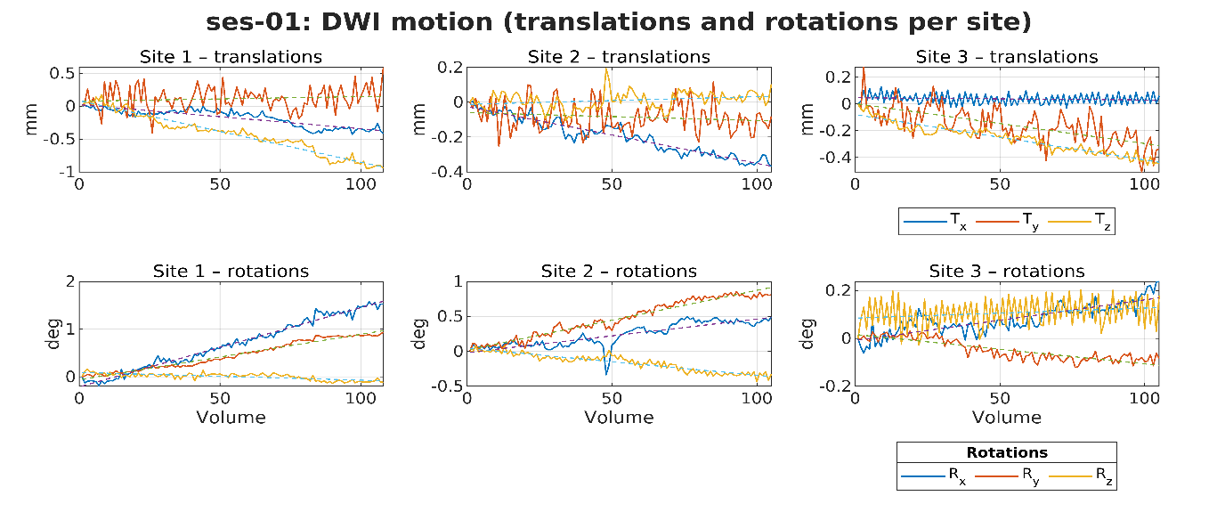
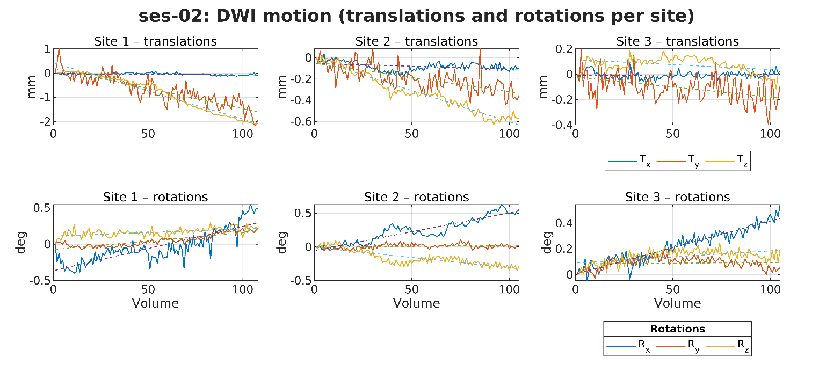
Figure S11; Motion estimates for DWI acquired across three sites. Translations (Tₓ, Tᵧ, T_{z}) reflect linear head displacement in mm. Rotational parameters (Rₓ, Rᵧ, R_{z}) represent rotations (°) around the same axes. The dashed line indicates the linear drift across the scan.

