Supplementary Information – Individuals born with congenital cataracts exhibit both persisting impairment and considerable recovery of white matter microstructure after sight restoration

Contents:
Participant information Pages 2-4
DC vs SC comparison and results Pages 4-6
Correlations with variables of interest Pages 7-13

Participant information
Supplementary table 1. Congenital cataract reversal participant details (adapted from Hölig et al. (2023) ²⁵)
Participant | Sex | Age (years) | Pre-surgery visual acuity ª | Age at surgery (y=years, m=months) | Time since surgery (y=years, m=months) | Visual acuity (logMAR) ª | Additional details
CC1 | M | 24 | N/A | 5 m | 24 y | 0.80 | Nystagmus, esotropia
CC2 | M | 36 | N/A | 2 y | 34 y | 0.40 | Nystagmus, esotropia
CC3 | M | 9 | CF at 3 m ^{b} | 7 y | 3 y | 0.80 | Nystagmus
CC4 | F | 6 | PL+, PR⁺ | 4 y | 2 y | 0.90 | Nystagmus
CC5 | F | 18 | CFCF ^{b} | 16 y | 3 y | CF at 1 m  (1.80 logMAR) | Nystagmus, exotropia, microcornea
CC6 | M | 32 | N/A | 6 y | 26 y | 1.30 | Nystagmus
CC7 | F | 28 | CFCF | 18 y | 10 y | 1.10 | Nystagmus, esotropia
CC8 | M | 11 | FFL | 5 m | 11 y | 0.90 | Nystagmus, esotropia
CC9 | M | 28 | N/A | 14 y | 15 y | 1.00 | Nystagmus, esotropia
CC10 | M | 13 | FFL | 1 y 3 m | 12 y | 0.30 | Nystagmus, exotropia
CC11 | M | 32 | N/A | 29 y 5 m | 3 y | 1.20^{c} | Nystagmus, esotropia
CC12 | F | 34 | 1.52 ^{c} | 31 y 4 m | 3 y 4 m | 1.1 | Nystagmus, exotropia
CC13 | F | 26 | N/A | 8 m | 26 y | 0.80 | Exotropia ^{d}
CC14 | F | 10 | FFL | 3 y 6 m | 7 y | 0.40 | Nystagmus, exotropia
CC15 | F | 7 | FFL | 3 m | 7 y | 0.80 | Nystagmus, esotropia
CC16 | F | 17 | CFCF ^{b} | 10 y 3 m | 7 y | 1.48ª | Nystagmus
CC17 | F | 11 | CF at 1 m ^{e} | 10 y 7 m | 6 m | 1.30 | Nystagmus
CC18 | M | 8 | FFL^{b} | 5 y 4 m | 3 y | 0.40 | Nystagmus, esotropia
CC19 | F | 18 | FFL at 1 m | 2 y 1 m | 16 y | 0.48 | Nystagmus, esotropia, microcornea
CC20 | M | 13 | CF at 0.5 m | 5 y 4 m | 8 y | 0.74 | Nystagmus, esotropia
Note. M = male; F = female; N/A = not available; FFL = fixing and following light; PL+ = able to perceive light; PR+ = able to report the location of light; CF = counting fingers; CFCF = counting fingers close to face. ªPositive logMAR values indicate the degree of vision loss, i.e., higher values denote lower visual acuity. ^{b}(Partially) absorbed cataracts. ^{c} Absorbed cataracts. ^{d}The presence of nystagmus was not reported in the medical file. ^{e}Neither retinal glow with retinoscopy nor fundus view with ophthalmoscopy was obtained prior to cataract surgery.

Supplementary table 2. Congenitally blind participant details (adapted from Hölig et al. (2023) ²⁵)
Participant | Sex | Age (years) | Visual acuity | Cause of blindness
CB1 | M | 39 | N/A | Microphthalmia OU
CB2 | M | 21 | NLP | Microphthalmia OU, microcornea OU
CB3 | F | 19 | PL⁺ | Microphthalmia OU
CB4 | M | 17 | PL⁺ | Phthisis bulbi OD, anterior staphyloma OS
CB5 | F | 19 | PL⁺ | Anterior staphyloma OD, phthisis bulbi OS
CB6 | M | 23 | CFCF | Corneal scar OU, microphthalmia OU
CB7 | M | 16 | PL⁺, PR⁺ | Microphthalmia OU, band-shaped Keratopathy OU
CB8 | F | 17 | NLP | Leber’s congenital amaurosis
Note. M = male; F = female; OU = both eyes; OD = right eye; OS = left eye; N/A = not available; FFL = fixing and following light; NLP = no light perception; PL+ = able to perceive light; PR+ = able to report the location of light; CFCF = counting fingers close to face.

Supplementary table 3. Developmental cataract participant details (adapted from Hölig et al. (2023) ²⁵)
Participant | Sex | Age (years) | Cataract onset ª | Pre-surgery visual acuity ^{b} | Age at surgery (y = years,  m = months) | Time since surgery (y = years,  m = months) | Visual acuity ^{b}
DC1 | M | 13 | Developmental | PL+, PR+ | 9 y | 4 y | 1.78
DC2 | M | 13 | Developmental | 0.80 | 12 y 6 m | 7 m | 0.10
DC3 | F | 43 | Age-related ^{c} | 0.60 | 40 y 4 m ^{d} | 3 y | 0.30
DC4 | M | 12 | Congenital | 0.80 | 11 y 10 m | 8 m | 0.60
DC5 | M | 9 | Developmental | 1.04 | 7 y 2 m | 2 y | 0.30
DC6 | M | 9 | Developmental | 0.90 | 7 y | 2 y | 0.10
DC7 | M | 17 | Developmental | 0.40 | 12 y 6 m | 5 y | 0.10
DC8 | M | 13 | Developmental | 1.00 | 8 y | 5 y | 0.20
DC9 | M | 11 | Developmental | 0.48 | 8 y 4 m | 4 y | 0.30
DC10 | F | 13 | Developmental | 0.50 | 10 y 2 m | 3 y | 0.10
DC11 | F | 21 | Developmental | 0.40 | 17 y 4 m | 4 y | 0.20
Note. M = male; F = female; PL+ = able to perceive light; PR+ = able to report the location of light, - = neither nystagmus nor strabismus reported in the medical records. ª Developmental cataracts typically develop gradually and remain unnoticed for some time; thus, it is not possible to define a clear onset. ^{b} Positive logMAR values indicate the degree of vision loss, i.e., higher values denote lower visual acuity. ^{c} The onset of cataracts was after the age of 12 years. ^{d} Operated only in one eye.

1.1 DC vs SC comparison
We consider the DC group to be a control group for the treatment (cataract surgery) rather than an experimental group, e.g., to determine the timing of sensitive periods. The main reasons are as follows:
First and foremost, it is important to note that the DC group is extremely variable. Inherently, developmental cataracts happen gradually and can go unnoticed for some time. Thus, defining the time of onset and duration of visual impairment is impossible. Second, as can be seen in supplementary table 3, the majority of participants had some level of vision prior to surgery, as intervention is typically sought prior to complete loss of vision.

1.2 DC vs SC results
DC individuals showed higher MD, RD and AD compared to SC individuals, primarily in some of the visual tracts (supplementary figure 1A, supplementary table 4), supported by higher average tract deviation for visual tracts (MD: 20.39, RD: 16.19, AD: 20.85) than non-visual tracts (MD: 1.80, RD: 2.02, AD: 8.67). More precisely, unlike in the CC vs. SC comparison, differences were primarily observed for early visual tracts, namely the left and right OR and the splenium. OR alterations differed from those of the CC group in location as well: they were prominent at the occipital terminals in the DC vs SC comparison but more central for the CC vs. SC comparison. Although the left and right IFOF also showed group differences, these exhibited no consistent pattern and were descriptively less extensive than for the CC vs. SC comparison. Lastly, while FA displayed fewer alterations than measures of diffusivity, overlapping group differences in the left and right ILF may be noteworthy, although no other metrics were altered in the same segments.

Supplementary table 4. Cluster masses and segment ranges for visual tracts for the DC vs. SC comparison.
Metric | L_OR | R_OR | Splenium | L_IFOF | R_IFOF | L_ILF | R_ILF | L_SLF | R_SLF
FA |  |  |  | 9.29 [81-84] | 11.01 [23-26] | 21.62 [77-83]  19.62 [88-95] | 13.86 [87-92]
MD | 64.33 [1-18] | 34.44 [6-19]  17.44 [23-29] | 10.4 [57-60]  29.74 [80-91] | 13.61 [60-65] |  |  | 13.56 [1-6]
RD | 50.56 [1-16] | 13.07 [11-15]  9.22 [89-92] | 12.94 [70-74]  26.21 [80-90] | 9.09 [82-85] | 10.75 [23-26] |  | 13.83 [1-6]
AD | 52.79 [1-19]  17.28 [41-47] | 20.53 [1-8]  22.46 [13-21]  34.89 [24-38]  9.5 [46-49] | 14.89 [93-98] | 15.33 [60-65]
Table note: Each entry refers to a cluster of significantly differences between developmental cataract reversal individuals and matched sighted controls, organized by tract, hemisphere and tensor metric. Multiple entries refer to multiple clusters. Clusters are reported as ‘cluster mass [segment range]’. L – Left; R – Right; OR – Optic radiation; IFOF – Inferior frontal-occipital fasciculus; ILF – Inferior longitudinal fasciculus, SLF – Superior longitudinal fasciculus; FA – Fractional anisotropy; MD – Mean diffusivity; RD – Radial diffusivity; AD – Axial diffusivity.

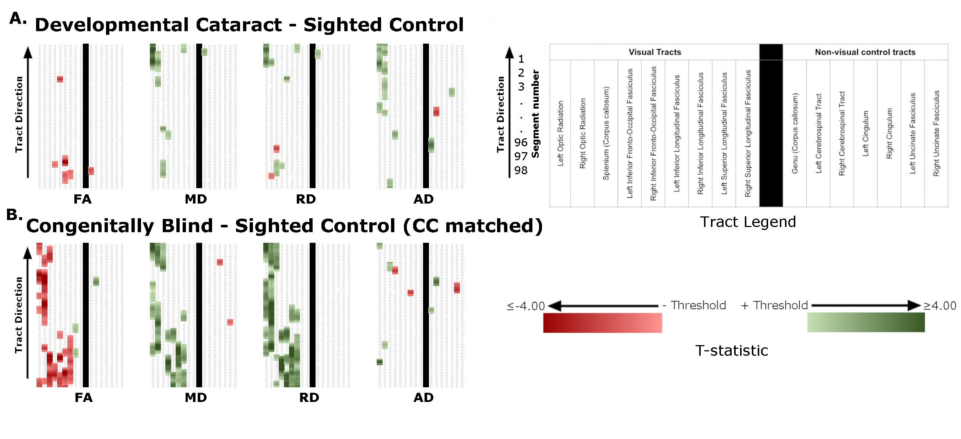
Supplementary figure 1: Overview of significant differences between groups. Each subplot shows significant differences in fractional anisotropy (FA), mean diffusivity (MD), radial diffusivity (RD) and axial diffusivity (AD) (labelled at the bottom). Each column represents a specific tract, for which 98 segments are displayed in rows, with downstream locations at the top. As indicated in the tract legend, tracts are organized from left to right as follows: Left Optic Radiation, Right Optic Radiation, Splenium, Left Inferior Fronto-Occipital Fasciculus, Right Inferior Fronto-Occipital Fasciculus, Left Inferior Longitudinal Fasciculus, Right Inferior Longitudinal Fasciculus, Left Superior Longitudinal Fasciculus, Right Superior Longitudinal Fasciculus, Genu, Left Corticospinal Tract, Right Corticospinal Tract, Left Cingulum, Right Cingulum, Left Uncinate Fasciculus, and Right Uncinate Fasciculus. The vertical black line indicates the separation of vision-related tracts (left) from non-visual control tracts (right). Clusters (p < 0.001) are coloured according to the direction of the difference, with relative shading reflecting the magnitude of difference at the segment level. For example, in A, developmental cataract reversal individuals vs matched sighted controls, green clusters indicate that the respective tensor metric was significantly greater for the developmental cataract reversal group than for normally sighted controls, while red clusters indicate the opposite. Additionally, clusters containing darker shades indicate larger group differences. This theme accordingly applies to B, permanently congenitally blind individuals (n=8) vs the sighted controls (n=15) originally matched to the congenital cataract reversal group.

Correlations with variables of interest
Supplementary table 5: Spearman’s rho values for the relationship between age at surgery and mean DTI metrics of visual tracts.
Tract | FA | MD | RD | AD
Left optic radiation | rs = 0.055 | rs = -0.124 | rs = -0.023 | rs = -0.138
Right optic radiation | rs = 0.305 | rs = 0.015 | rs = -0.060 | rs = 0.072
Splenium | rs = 0.028 | rs = 0.111 | rs = 0.107 | rs = 0.221
Left IFOF | rs = 0.346 | rs = -0.137 | rs = -0.186 | rs = 0.162
Right IFOF | rs = 0.312 | rs = 0.002 | rs = -0.121 | rs = 0.150
Left ILF | rs = 0.413 | rs = -0.136 | rs = -0.243 | rs = 0.110
Right ILF | rs = 0.099 | rs = 0.106 | rs = 0.061 | rs = 0.161
Left SLF | rs = 0.259 | rs = -0.137 | rs = -0.224 | rs = 0.357
Right SLF | rs = 0.196 | rs = -0.033 | rs = -0.153 | rs = 0.137
Table note: Spearman’s rho values are reported for the correlation between each tract’s mean metric values and age at surgery in months. Only congenital cataract reversal individuals were included. No significant correlations were revealed. FA – Fractional anisotropy; MD – Mean diffusivity; RD – Radial diffusivity; AD – Axial diffusivity; IFOF – inferior fronto-occipital fasciculus; ILF – inferior longitudinal fasciculus; SLF - superior longitudinal fasciculus.

Supplementary table 6: Spearman’s rho values for the relationship between time since surgery and mean DTI metrics of visual tracts.
Tract | FA | MD | RD | AD
Left optic radiation | rs = 0.181 | rs = -0.059 | rs = -0.182 | rs = 0.086
Right optic radiation | rs = 0.060 | rs = -0.297 | rs = -0.265 | rs = -0.214
Splenium | rs = 0.125 | rs = -0.257 | rs = -0.251 | rs = -0.362
Left IFOF | rs = -0.006 | rs = -0.127 | rs = -0.120 | rs = -0.226
Right IFOF | rs = 0.072 | rs = -0.333 | rs = -0.237 | rs = -0.326
Left ILF | rs = -0.187 | rs = -0.048 | rs = 0.026 | rs = -0.206
Right ILF | rs = 0.096 | rs = -0.296 | rs = -0.255 | rs = -0.295
Left SLF | rs = -0.020 | rs = -0.103 | rs = -0.059 | rs = -0.481*
Right SLF | rs = 0.017 | rs = -0.276 | rs = -0.109 | rs = -0.368
Table note: Spearman’s rho values are reported for the correlation between each tract’s mean metric values and time since surgery in months. Only congenital cataract reversal individuals were included. AD values in the left SLF were significantly correlated to time since surgery (p = 0.037), but this did not survive multiple comparisons correction. FA – Fractional anisotropy; MD – Mean diffusivity; RD – Radial diffusivity; AD – Axial diffusivity; IFOF – inferior fronto-occipital fasciculus; ILF – inferior longitudinal fasciculus; SLF - superior longitudinal fasciculus.

Supplementary table 7: Spearman’s rho values for the relationship between visual acuity and mean DTI metrics of visual tracts.
Tract | FA | MD | RD | AD
Left optic radiation | rs = -0.023 | rs = -0.001 | rs = 0.105 | rs = -0.165
Right optic radiation | rs = 0.180 | rs = 0.129 | rs = 0.069 | rs = 0.052
Splenium | rs = 0.373 | rs = -0.112 | rs = -0.201 | rs = 0.006
Left IFOF | rs = 0.233 | rs = 0.004 | rs = -0.025 | rs = 0.176
Right IFOF | rs = 0.226 | rs = 0.057 | rs = -0.013 | rs = 0.050
Left ILF | rs = 0.265 | rs = 0.031 | rs = -0.085 | rs = 0.085
Right ILF | rs = 0.101 | rs = 0.065 | rs = 0.040 | rs = 0.190
Left SLF | rs = -0.075 | rs = -0.081 | rs = -0.057 | rs = 0.086
Right SLF | rs = 0.058 | rs = 0.024 | rs = -0.041 | rs = 0.104
Table note: Spearman’s rho values are reported for the correlation between each tract’s mean metric values and visual acuity reported as logMAR values (higher values indicate lower visual acuity). Only congenital cataract reversal individuals were included. No significant correlations were revealed. FA – Fractional anisotropy; MD – Mean diffusivity; RD – Radial diffusivity; AD – Axial diffusivity; IFOF – inferior fronto-occipital fasciculus; ILF – inferior longitudinal fasciculus; SLF - superior longitudinal fasciculus.

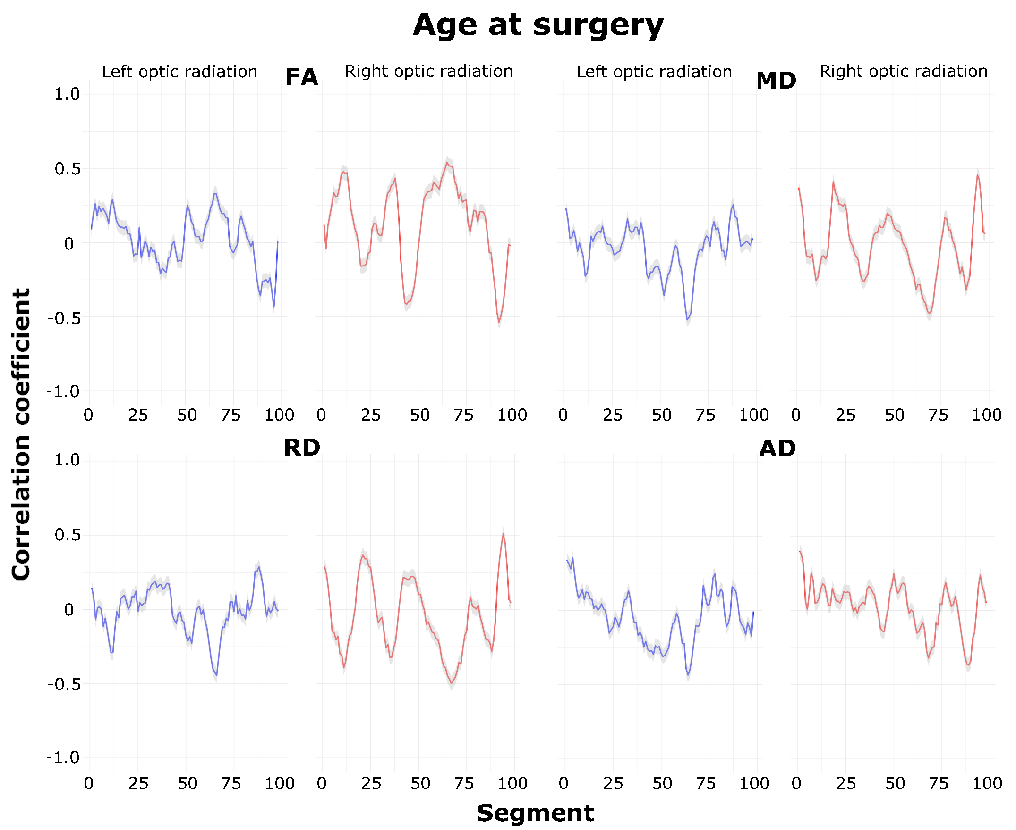Supplementary figure 2: Correlation between age at surgery and DTI metrics along the length of the optic radiations (for the CC group). Each plot shows the mean correlation
between DTI metrics and age at surgery for each segment along the length of the left and right optic radiations. Shading around the mean line signifies the standard deviation. No significant correlations remained following FDR correction.

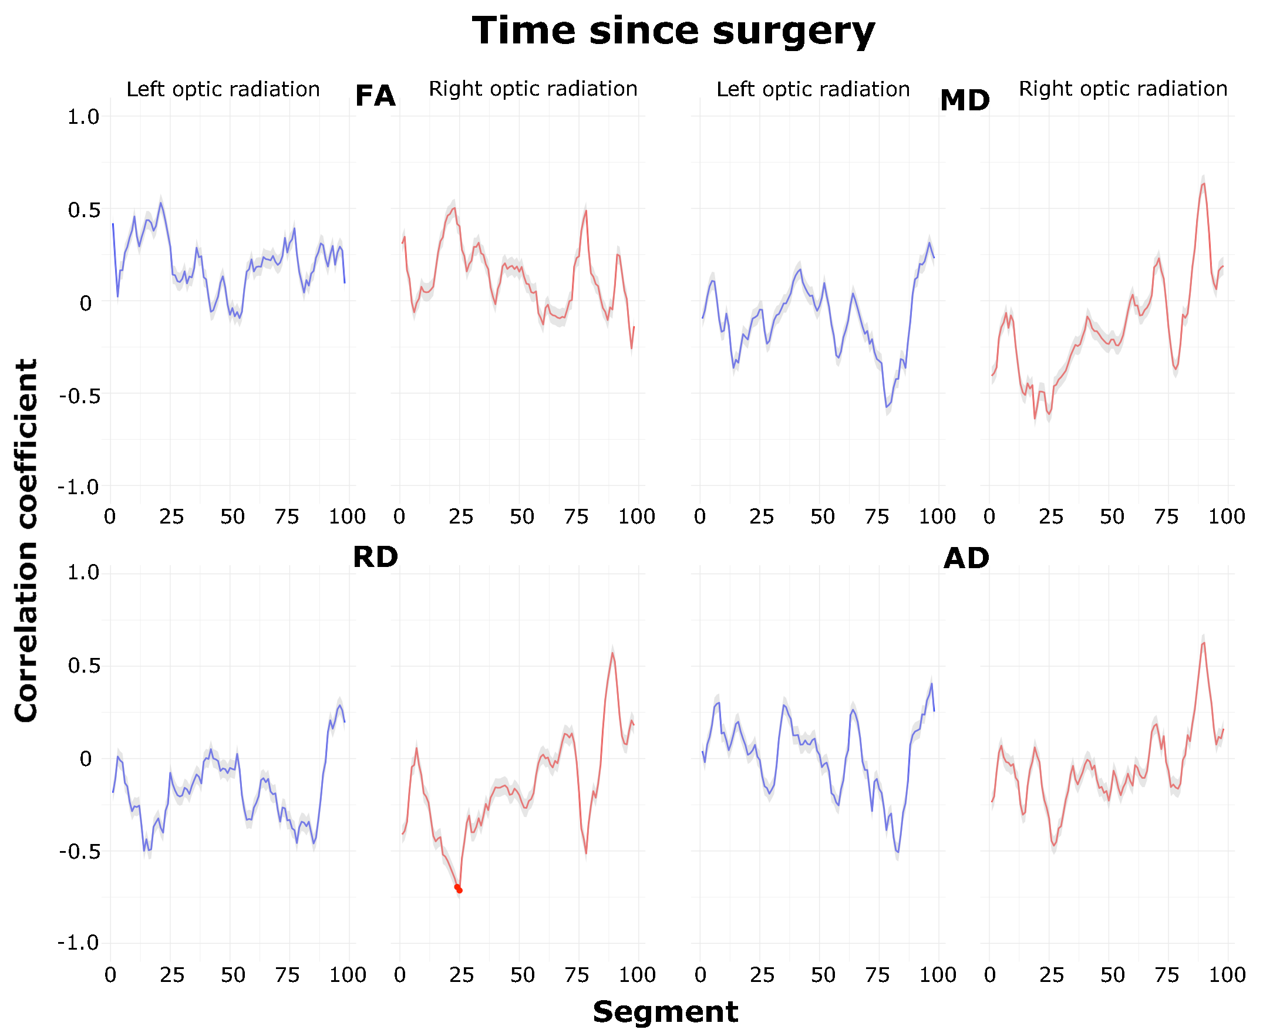 Supplementary figure 3: Correlation between time since surgery and DTI metrics along the length of the optic radiations (for the CC group). Each plot shows the mean spearman correlation between DTI metrics and time since surgery for each segment along the length of the left and right optic radiations. Shading around the mean line signifies the standard deviation. Significant correlations (p^{FDR}<0.05) are indicated by dots for the relevant segments.

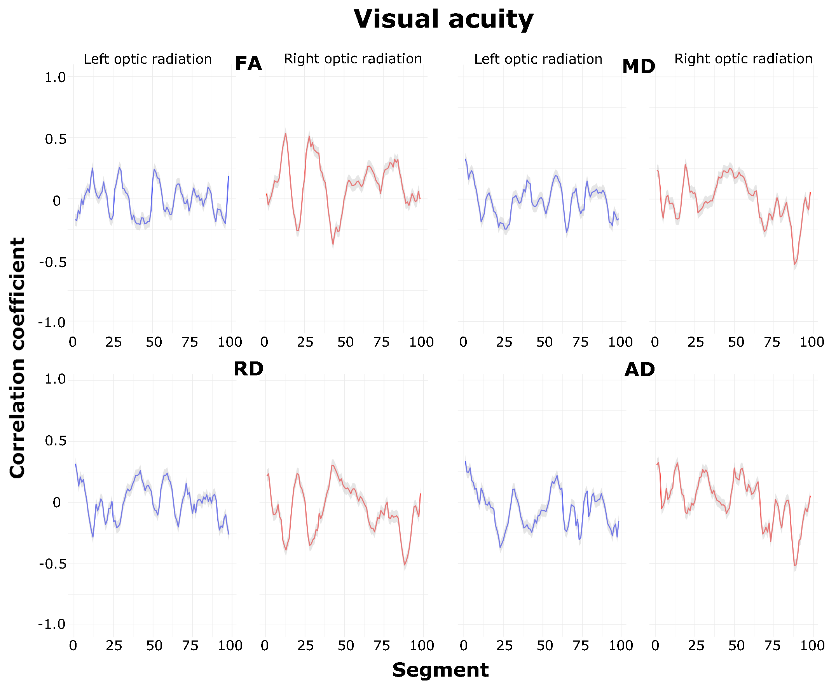 Supplementary figure 4: Correlation between visual acuity and DTI metrics along the length of the optic radiations (for the CC group). Each plot shows the mean correlation between DTI metrics and visual acuity for each segment along the length of the left and right optic radiations. Shading around the mean line signifies the standard deviation. No significant correlations remained following FDR correction.

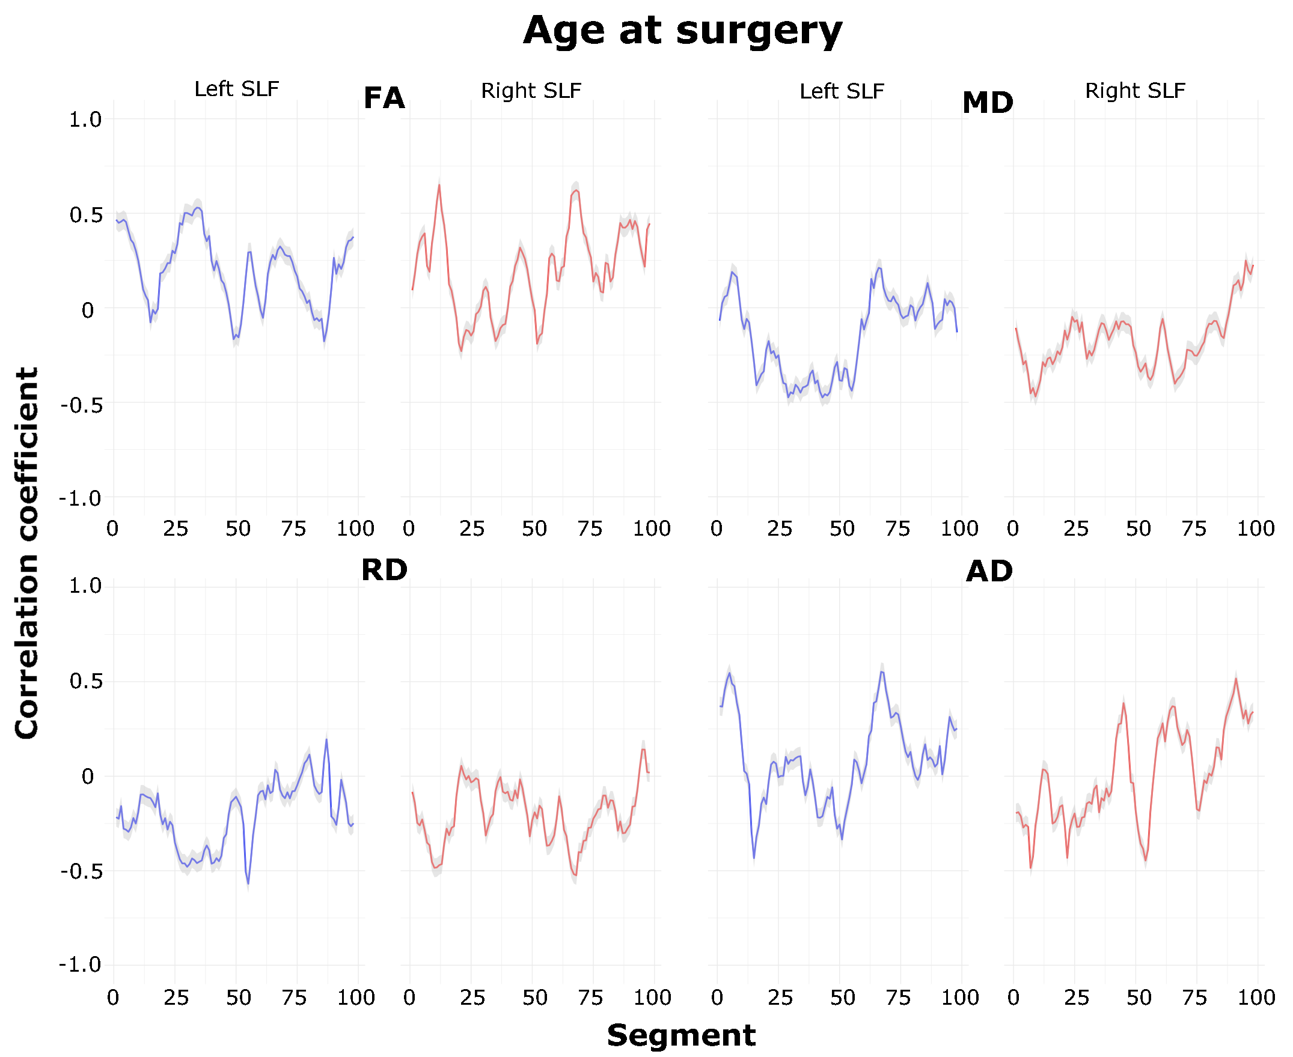 Supplementary figure 5: Correlation between age at surgery and DTI metrics along the length of the superior longitudinal fasciculi (for the CC group). Each plot shows the mean spearman correlation between DTI metrics and age at surgery for each segment along the length of the left and right superior longitudinal fasciculi. Shading around the mean line signifies the standard deviation. No significant correlations remained following FDR correction.
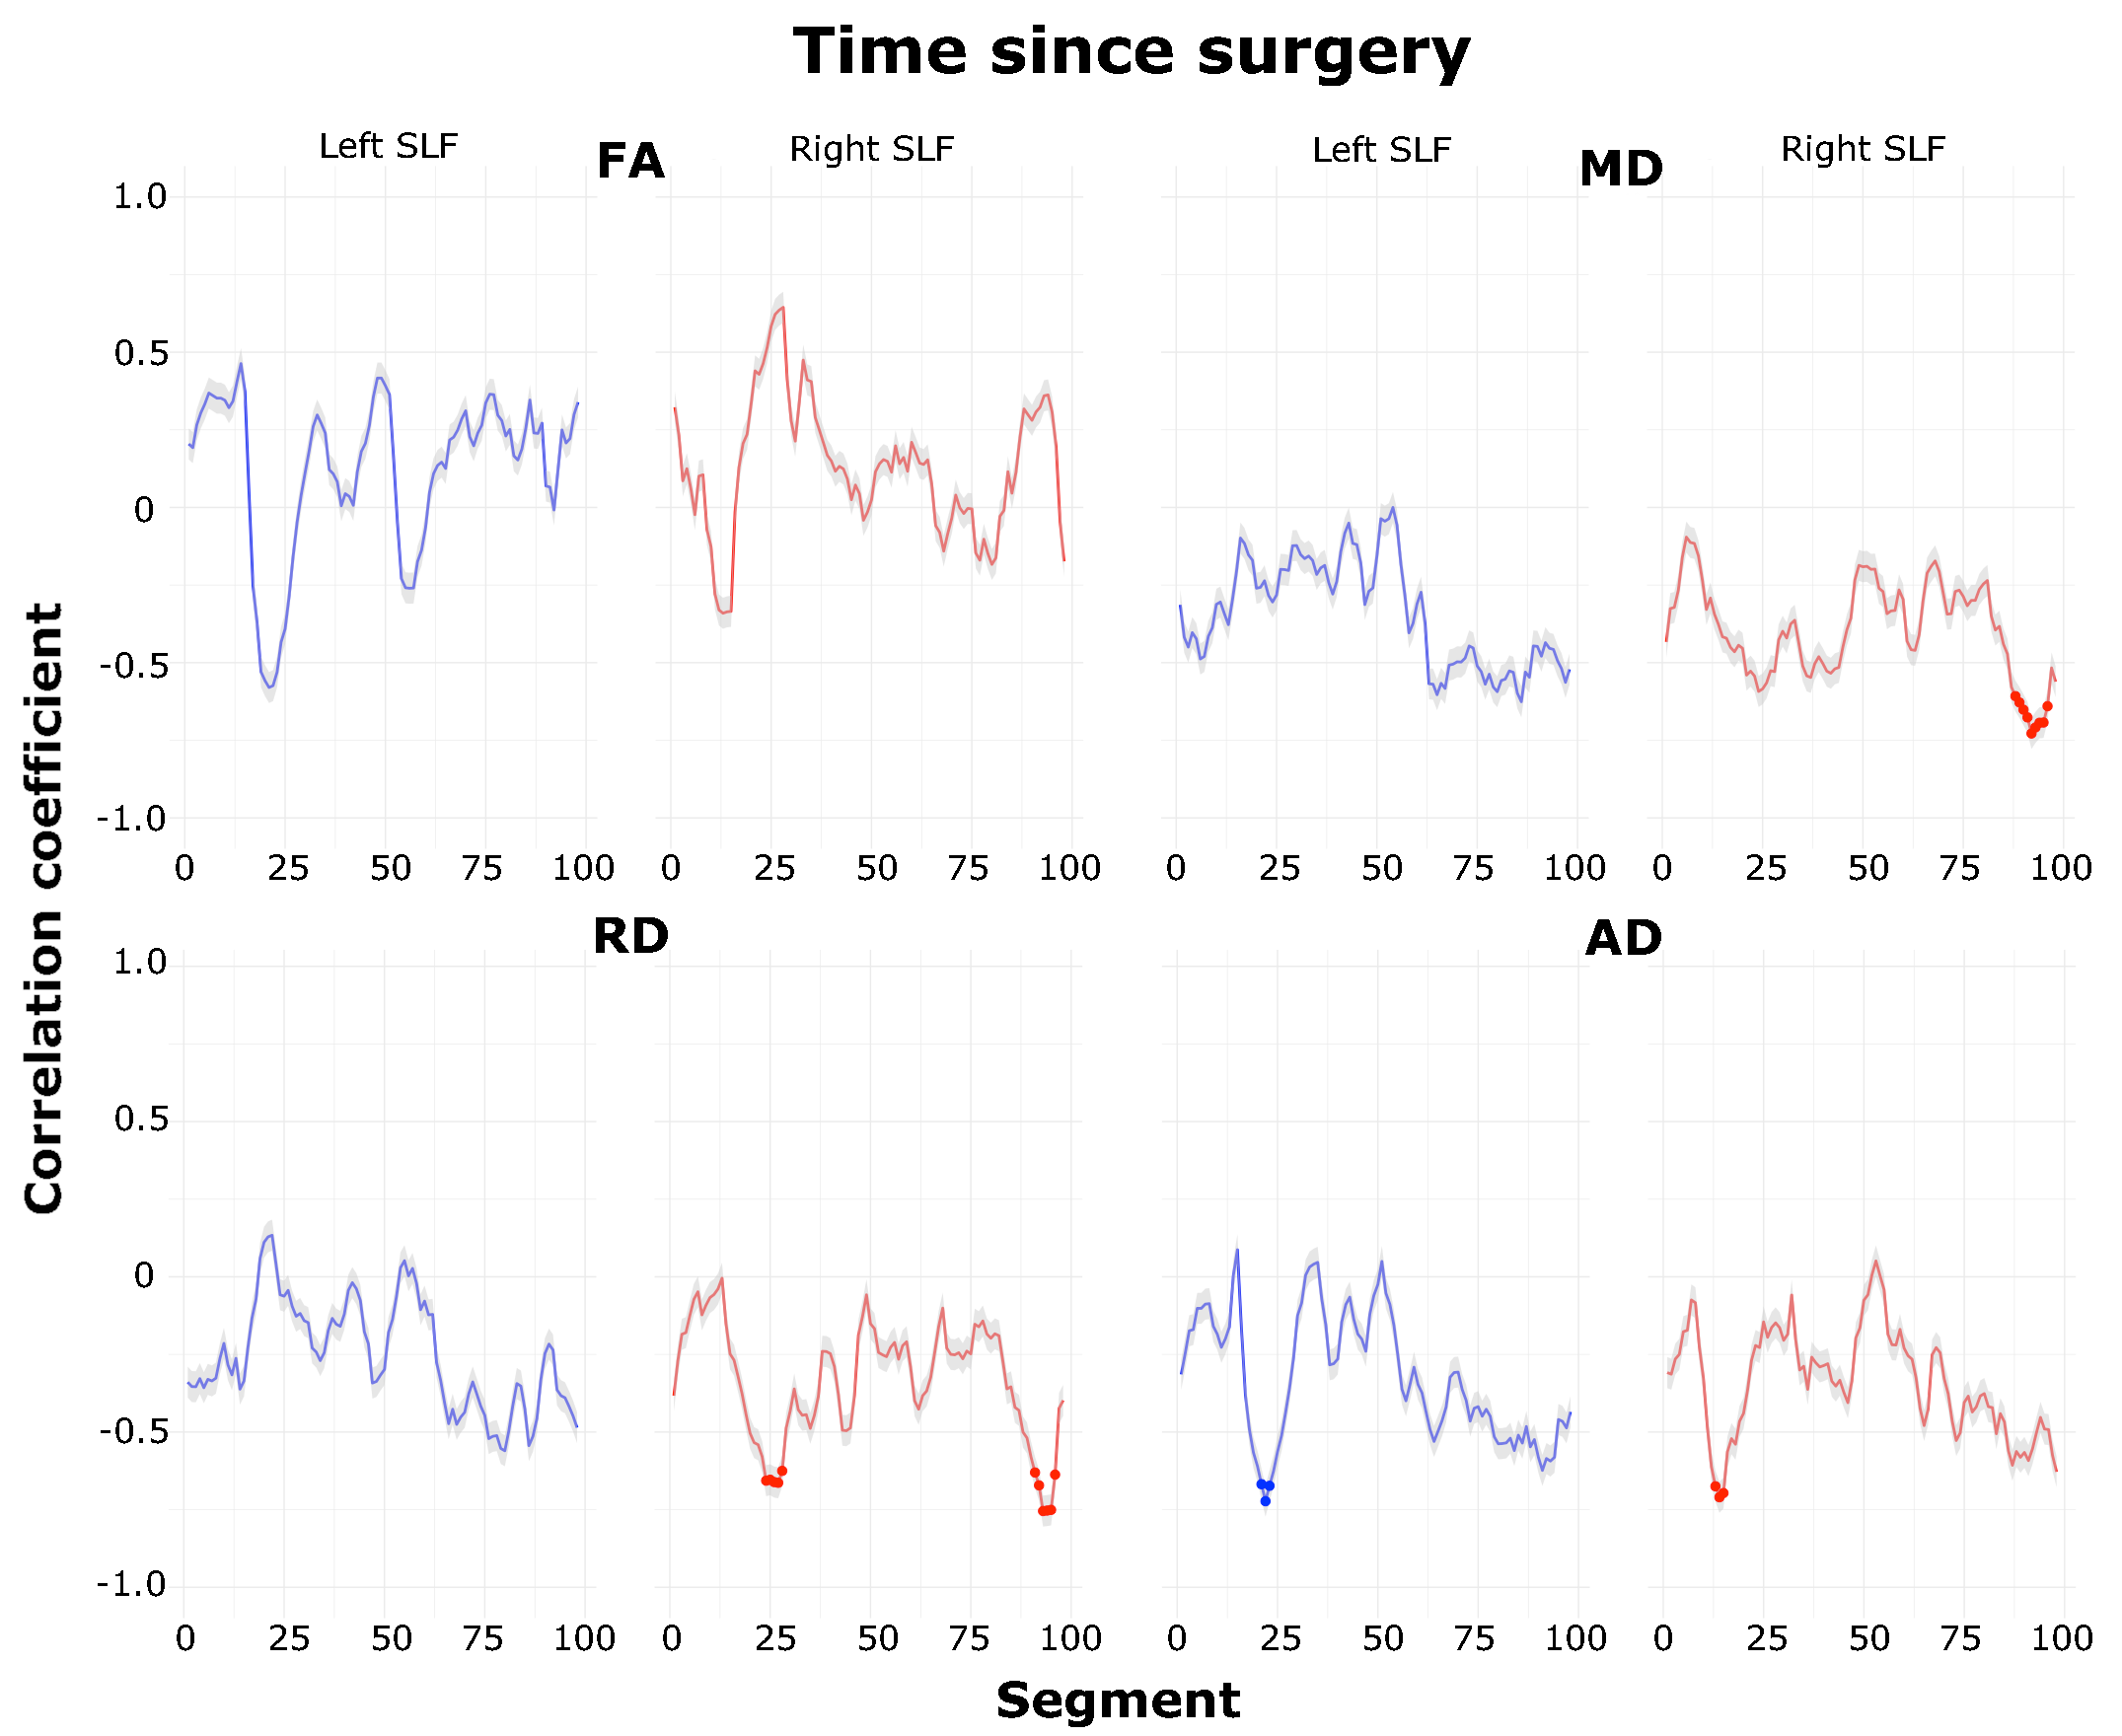 Supplementary figure 6: Correlation between time since surgery and DTI metrics along the length of the superior longitudinal fasciculi (for the CC group). Each plot shows the mean spearman correlation between DTI metrics and time since surgery for each segment along the length of the left and right superior longitudinal fasciculi. Shading around the mean line signifies the standard deviation. Significant correlations (p^{FDR}<0.05) are indicated by dots for the relevant segments.

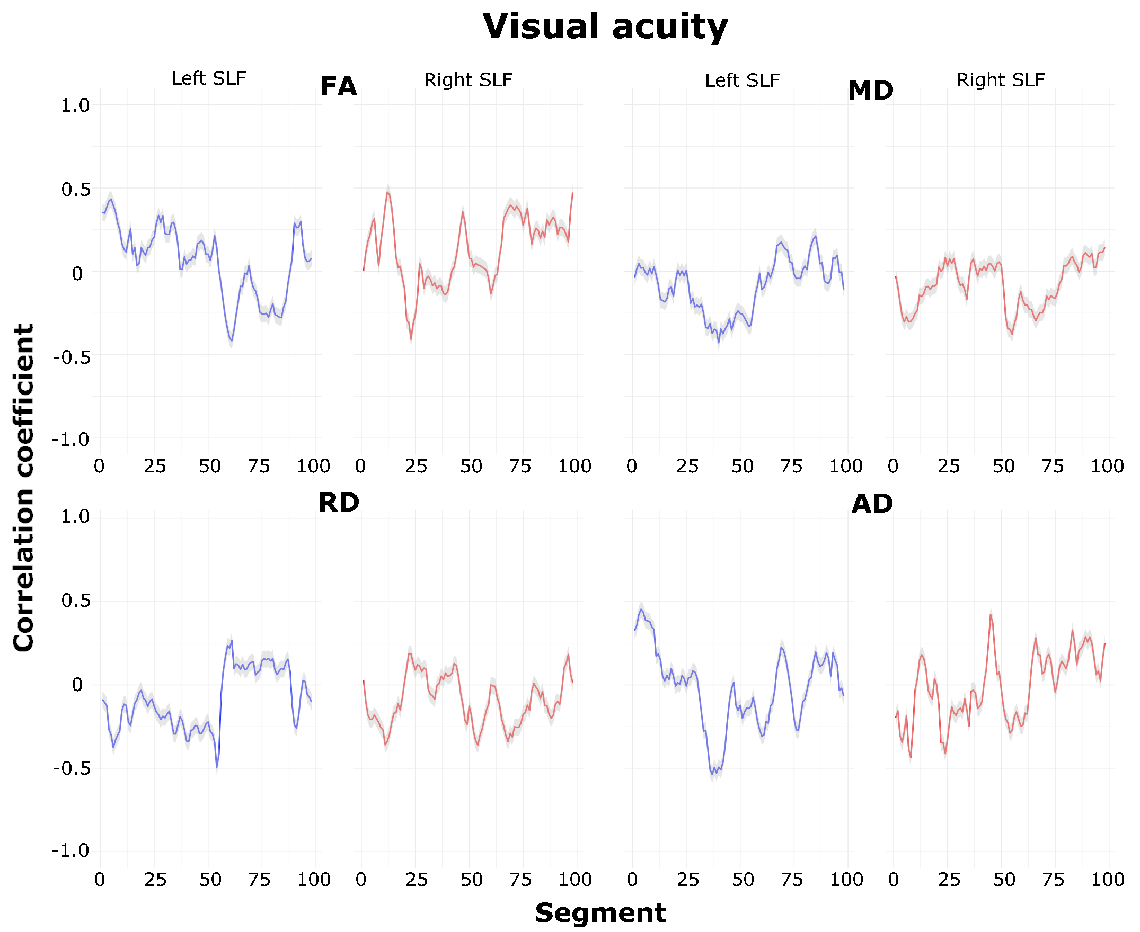 Supplementary figure 7: Correlation between visual acuity and DTI metrics along the length of the superior longitudinal fasciculi (for the CC group). Each plot shows the mean spearman correlation between DTI metrics and visual acuity for each segment along the length of the left and right superior longitudinal fasciculi. Shading around the mean line signifies the standard deviation. No significant correlations remained following FDR correction.

