Supplementary:
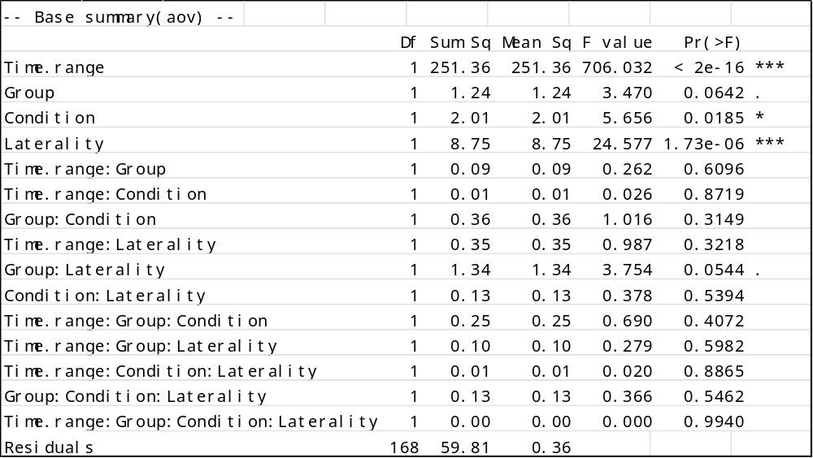
Supplementary table 1. Results of the four-way ANOVA for the Group-based model on baseline-corrected beta (z-scored beta power, 14–30 Hz; window mean minus Rest). Factors: Time window (Time.range; ERD, ERS), Group (Healthy Controls, HC; ALS patients, ALS), Condition (Active, Passive), and Laterality (contralateral, Contra; ipsilateral, Ipsi). “:” denotes interactions. Reported are degrees of freedom (Df), sum of squares (SS), mean square (MS), F, and p. (Signif. codes: 0 ‘’ 0.001 ‘’ 0.01 ‘’ 0.05 ‘.’ 0.1 ‘ ’ 1)
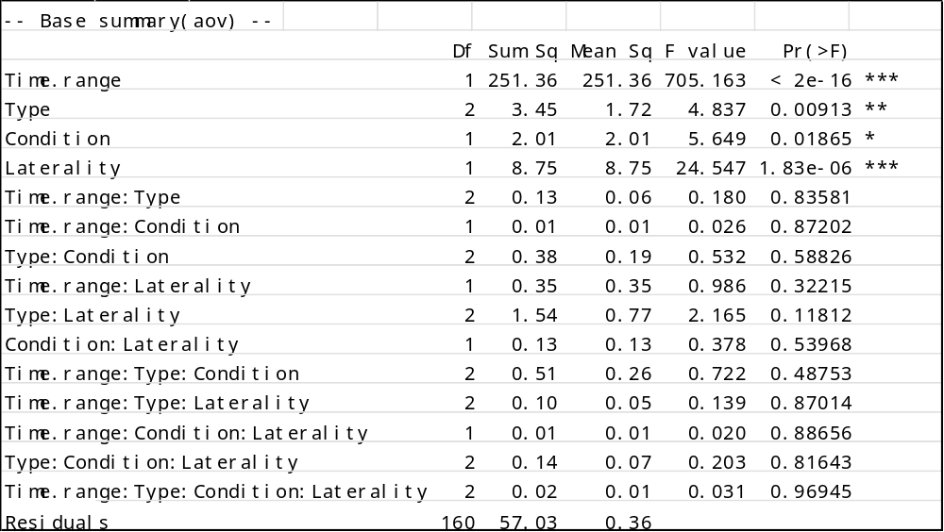
Supplementary table 2 Results of the four-way ANOVA for the Type-based model on baseline-corrected beta (z-scored beta power, 14–30 Hz; window mean minus Rest). Factors: Time window (ERD, ERS), Type (HC; ALS with preserved hand strength, ALS-Strong; ALS with impaired hand strength, ALS-Weak), Condition (Active, Passive), and Laterality (Contra, Ipsi). “:” denotes interactions. Reported are Df, SS, MS, F, and p. (Signif. codes: 0 ‘’ 0.001 ‘’ 0.01 ‘’ 0.05 ‘.’ 0.1 ‘ ’ 1)

Correlation: ALSFRS-r - Contralateral ΔZ Beta power
Condition | Time | Correlation (ρ) | 95% CI Lower | 95% CI Upper | P-Holm
Active | ERD | -0.071 | -0.671 | 0.585 | 0.845
Active | ERS | -0.414 | -0.828 | 0.292 | 0.469
Passive† | ERD | -0.591 | -0.890 | 0.061 | 0.072
Passive†† | ERS | -0.696 | -0.922 | -0.118 | 0.051
Correlation: PUMNS - Contralateral ΔZ Beta power
Active | ERD | -0.307 | -0.766 | 0.359 | 0.718
Active | ERS | -0.061 | -0.637 | 0.559 | 0.859
Passive | ERD | 0.288 | -0.377 | 0.757 | 0.590
Passive | ERS | 0.348 | -0.319 | 0.784 | 0.590
Supplementary table 3. Pearson correlations between baseline-corrected beta (z-scored beta power; window minus Rest) and clinical measures in ALS only (contralateral hemisphere). Correlations are reported separately for Condition (Active, Passive) and Time window (ERD, ERS). Entries show ρ, 95% CI, and p; p(Holm) denotes Holm-adjusted p-values within each Measure × Condition family (two tests: ERD, ERS). For ALSFRS-r one patient lacked a score (n = 10 for ALSFRS-r; n = 11 for PUMNS and MRC right-finger). No correlations survived Holm correction. See Supplementary figure 1A† and 1B†† for example correlation plot.

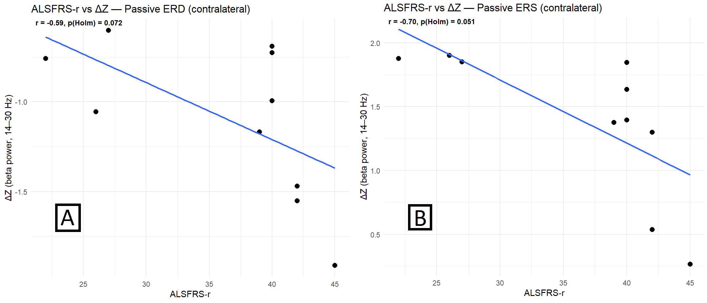
Supplementary figure 1. Examples of correlation of clinical scores and baseline-corrected beta power. A: ρ =-0.591 p = 0.072, B: ρ=-0.696, p = 0.051. See Supplementary table 3 for more.

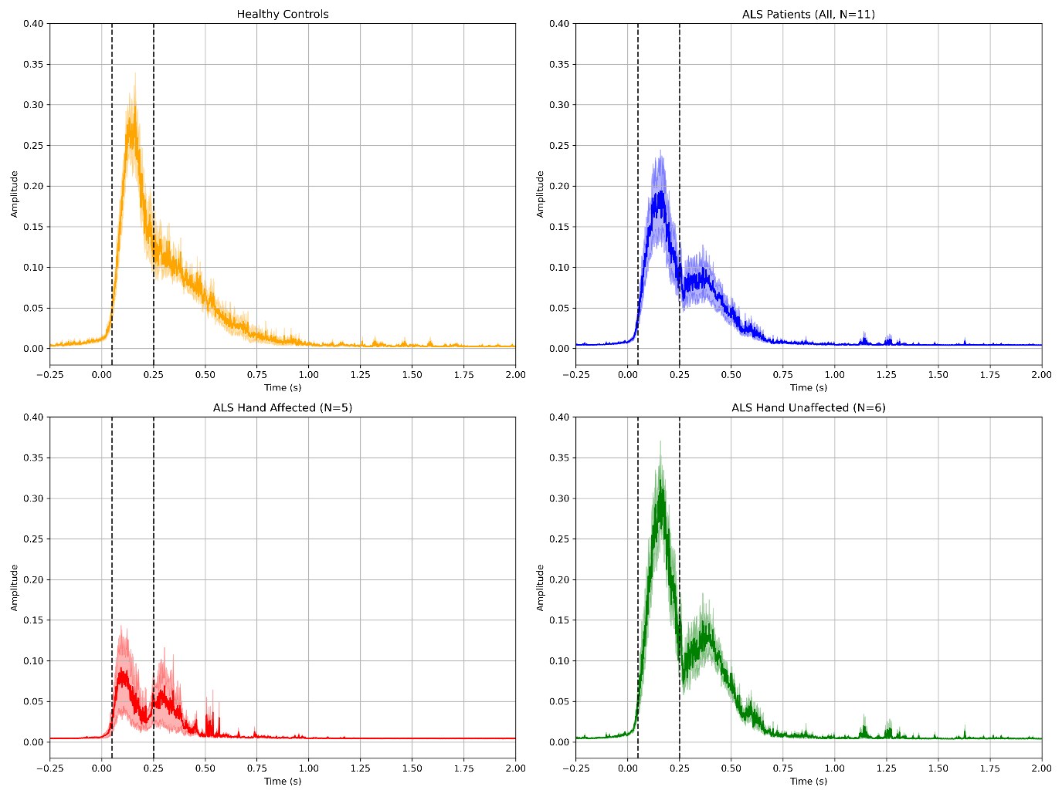
Supplementary figure 2. Active condition. Average accelerometer amplitude. All traces are aligned to the movement marker (MM). Shaded area is ± standard error of the mean. Yellow = HC (n=12), Blue = ALS group (n=11), Red = ALS (affected hand)” and Green = ALS (unaffected hand).. Black dotted lines show an interval selected for statistical tests (0.05-0.25s).

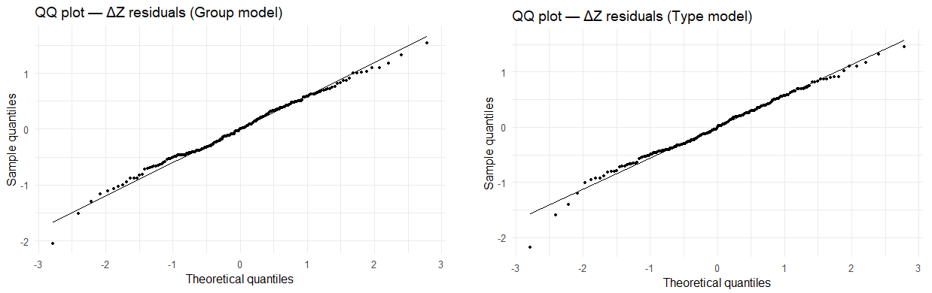
Supplementary figure 3. Q–Q plots of standardized baseline-corrected beta residuals from the two four‑way ANOVA models. Left: Group model (ALS vs HC). Right: Subtype model (HC, ALS‑Strong, ALS‑Weak). Points follow the 45° reference line closely, with the plots indicating minor departures from normality but no serious heteroscedasticity.

Group / Subtype | Baseline - uncorrected beta Baseline (Rest) | Baseline-uncorrected beta  ERD | Absolute ERD drop (Baselin-ERD) | Baseline-uncorrected beta  ERS | Absolute ERS rise (ERS -Baseline)
HC | 5.55 | 3.69 | 1.86 | 7.29 | 1.74
ALS (all) | 5.58 | 3.55 | 2.03 | 6.85 | 1.27
ALS Strong | 7.36 | 4.28 | 3.08 | 8.92 | 1.56
ALS Weak | 3.44 | 2.67 | 0.77 | 4.37 | 0.93
Supplementary table 4. All baseline-uncorrected beta values expressed as x*10⁻²² (T m⁻¹)² Hz⁻¹. Means of baseline-uncorrected beta‑band power in each analysis time window, together with and baseline‑normalized (relative) ERD/ERS values.

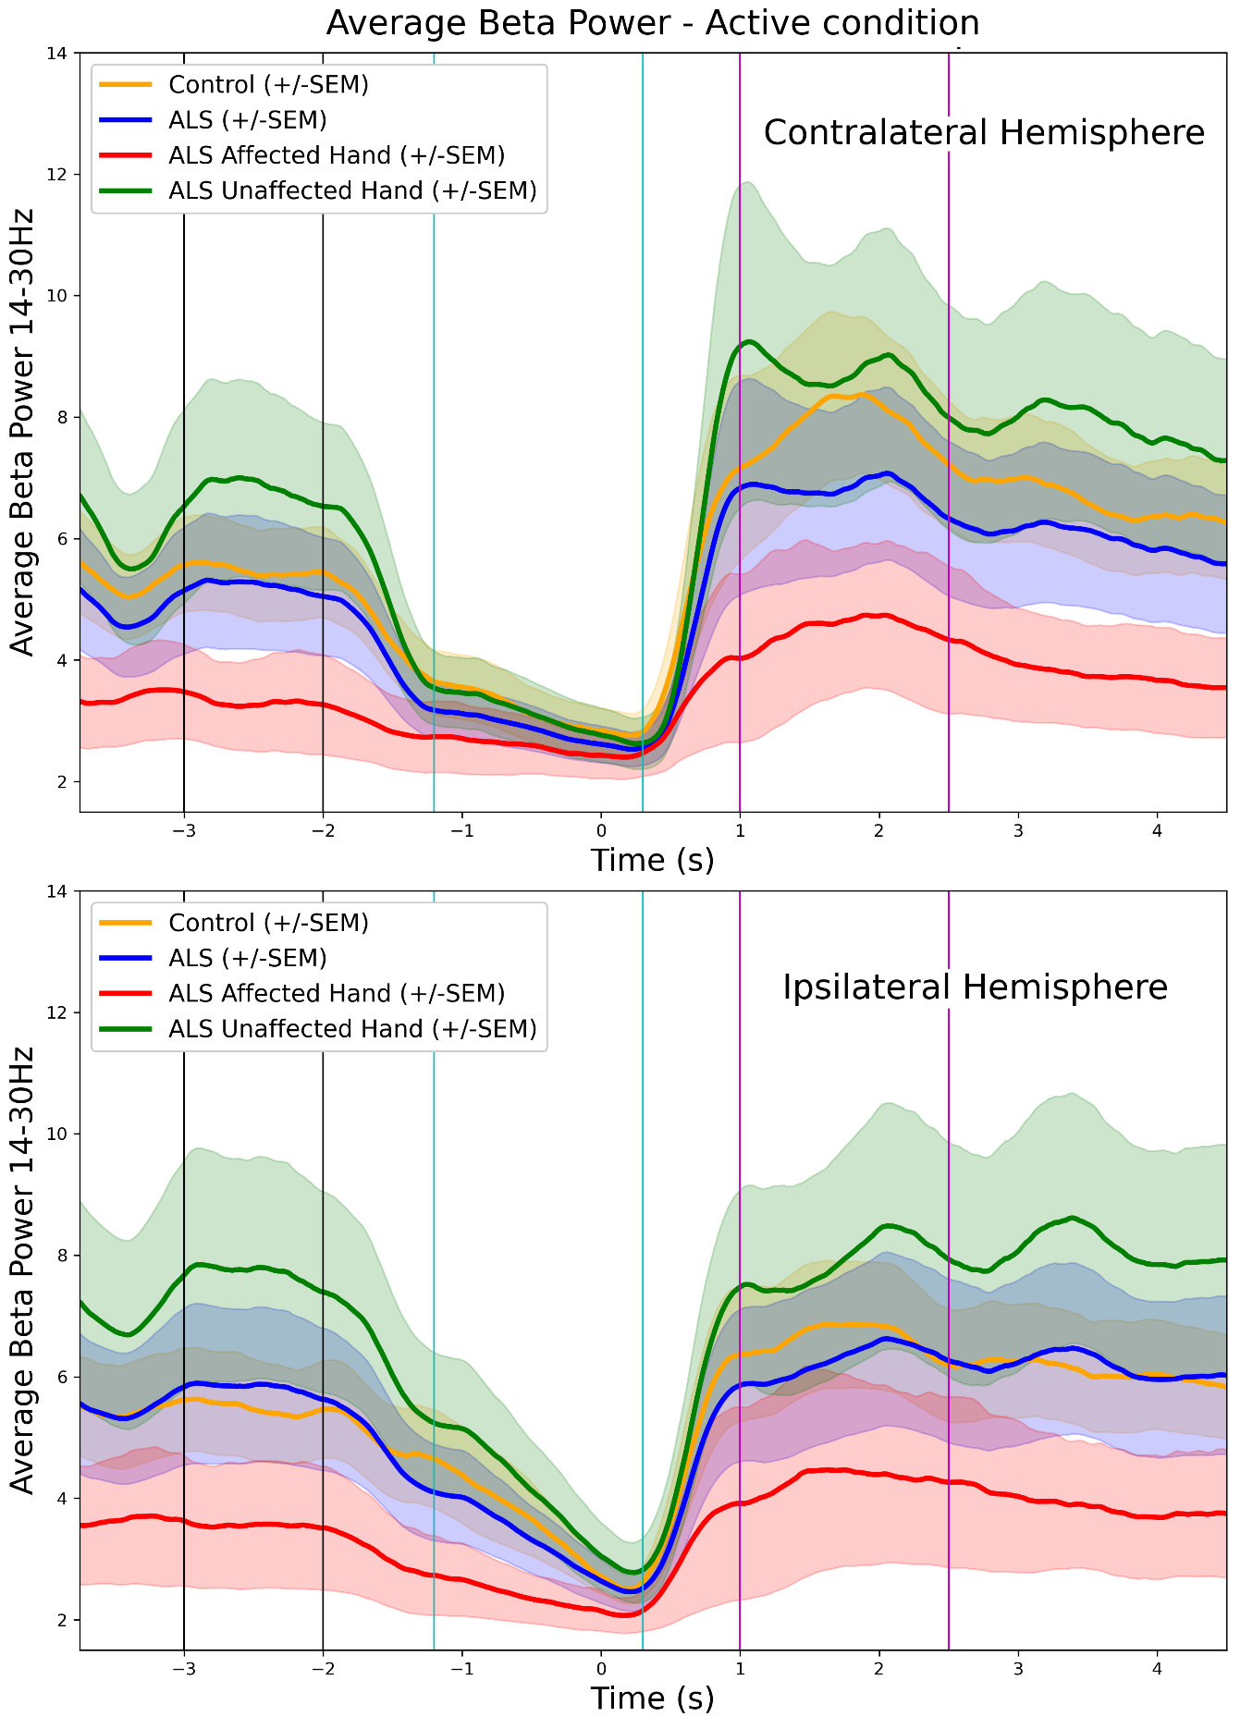
Supplementary figure 4. Average baseline-uncorrected beta power (14-30 Hz) for the active condition, contralateral- (top) and Ipsilateral- (bottom) hemisphere. Vertical lines illustrate the time windows selected for the further analysis Black=baseline, Teal=ERD, Purple=ERS. All values presented as (x*10⁻²² (T m⁻¹)² Hz⁻¹). t0 is movement onset registered by the accelerometer and MM registration.

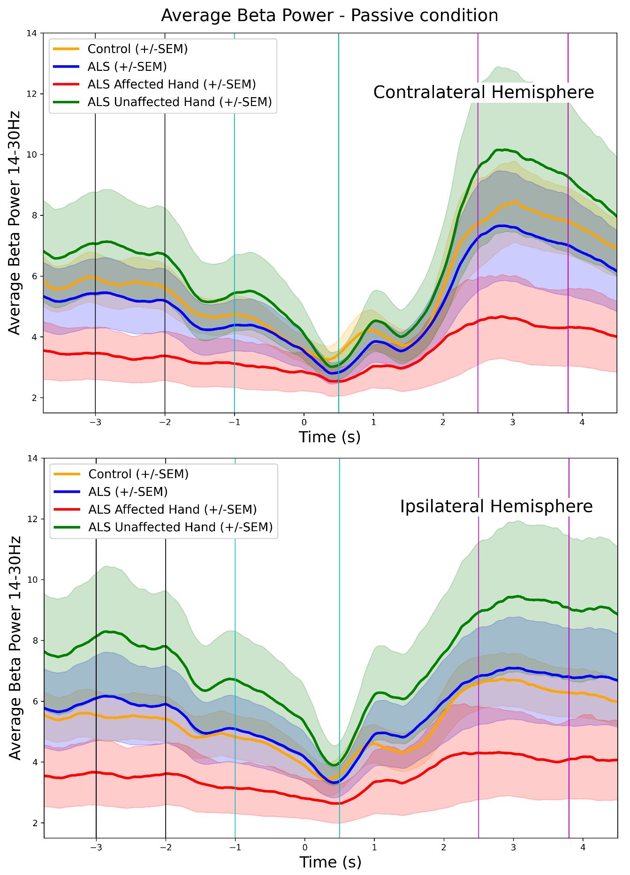
Supplementary figure 5. Average baseline-uncorrected beta power (14-30 Hz) for the passive condition, contralateral- (top) and Ipsilateral- (bottom) hemisphere. Vertical lines illustrate the time windows selected for the further analysis Black=baseline, Teal=ERD, Purple=ERS. All values presented as (x*10⁻²² (T m⁻¹)² Hz⁻¹). t0 is movement onset registered by the accelerometer and MM registration

