Supplementary material for:

Title: Towards repeatable and converging methods in diffusion MRI: Evidence from a longitudinal chronic pain cohort

Authors: Fortier, Marc-Antoine^{1,2,4}; Little, Graham^{1,3,4}; Bautin, Paul^{1,2,4}; Sean, Monica^{1,2,4}; Tétreault, Pascal^{1,2,4};

Affiliations:
¹ Faculty of medicine and health sciences, Université de Sherbrooke, Québec, Canada
² Centre de recherche du CHUS, Sherbrooke, Québec, Canada
³ Jump Ship Labs, Edmonton, Alberta, Canada
⁴ Department of Anesthesiology, Sherbrooke, Québec, Canada

Corresponding Author: Pascal Tétreault
Corresponding Author Email: Pascal.Tetreault@USherbrooke.ca
Supplementary material

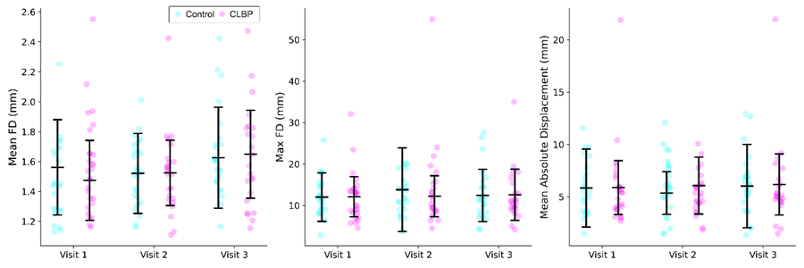

Figure S1. Comparison of diffusion MRI motion parameters between chronic low back pain (CLBP) and control groups across three visits. Each panel displays a different motion metric derived from rigid-body registration (mcflirt) of the denoised, pre-eddy-corrected DWI volumes: (A) mean framewise displacement, (B) maximum framewise displacement, and (C) mean absolute displacement relative to the first volume. Rotational parameters were converted to millimeters, assuming a 50 mm radius sphere. Individual data points represent single scan sessions; black lines and error bars indicate group means and standard deviations. No significant differences were observed between groups at any visit for any metric (independent-samples t-tests, all p > 0.15).
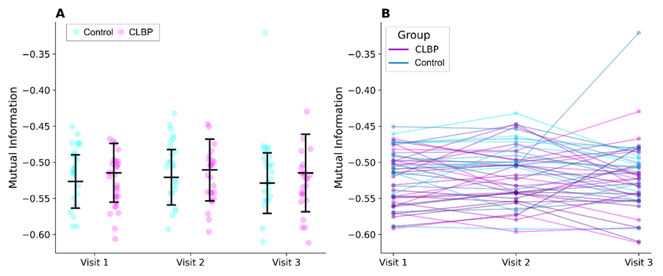

Figure S2. T1-to-dMRI co-registration quality assessed via mutual information (MI) between the ANTs-registered T1 and the b0 reference image within a brain mask. (A) Beeswarm plot comparing MI between chronic low back pain (CLBP) and control groups at each visit. Individual data points represent single scan sessions; black lines and error bars indicate group means and standard deviations. No significant group differences were observed at any visit (independent-samples t-tests, all p > 0.27). (B) Longitudinal MI trajectories for subjects with all three visits (CLBP: n = 23, Control: n = 24), with each line connecting a single subject's MI values across visits. Within-subject variability in MI did not differ between groups (p = 0.649), indicating consistent co-registration quality across timepoints in both groups.
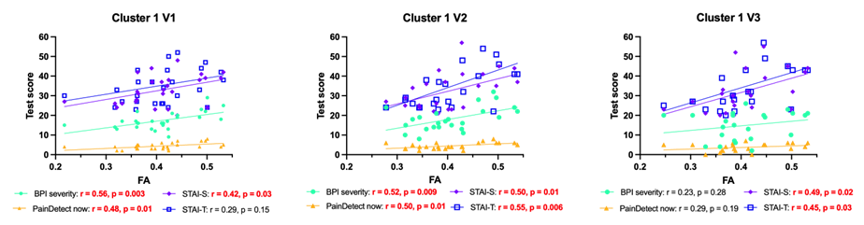

Figure S3. Exploratory structural correlation with functional pain characteristics. Four pain characteristics (BPI severity, PainDetect now, STAI-S, STAI-T) were plotted as a function of FA values in cluster 1 for every CLBP for every visit (V1, V2, V3). Correlations were calculated using Pearson’s correlation coefficient (r) and significant correlations are shown in red. BPI severity: severity component of the Brief Pain Inventory. PainDetect now: reported pain scale at time of sampling. STAI-S: state component of the State and Trait Anxiety Inventory. STAI-T: trait component of the State and Trait Anxiety Inventory.

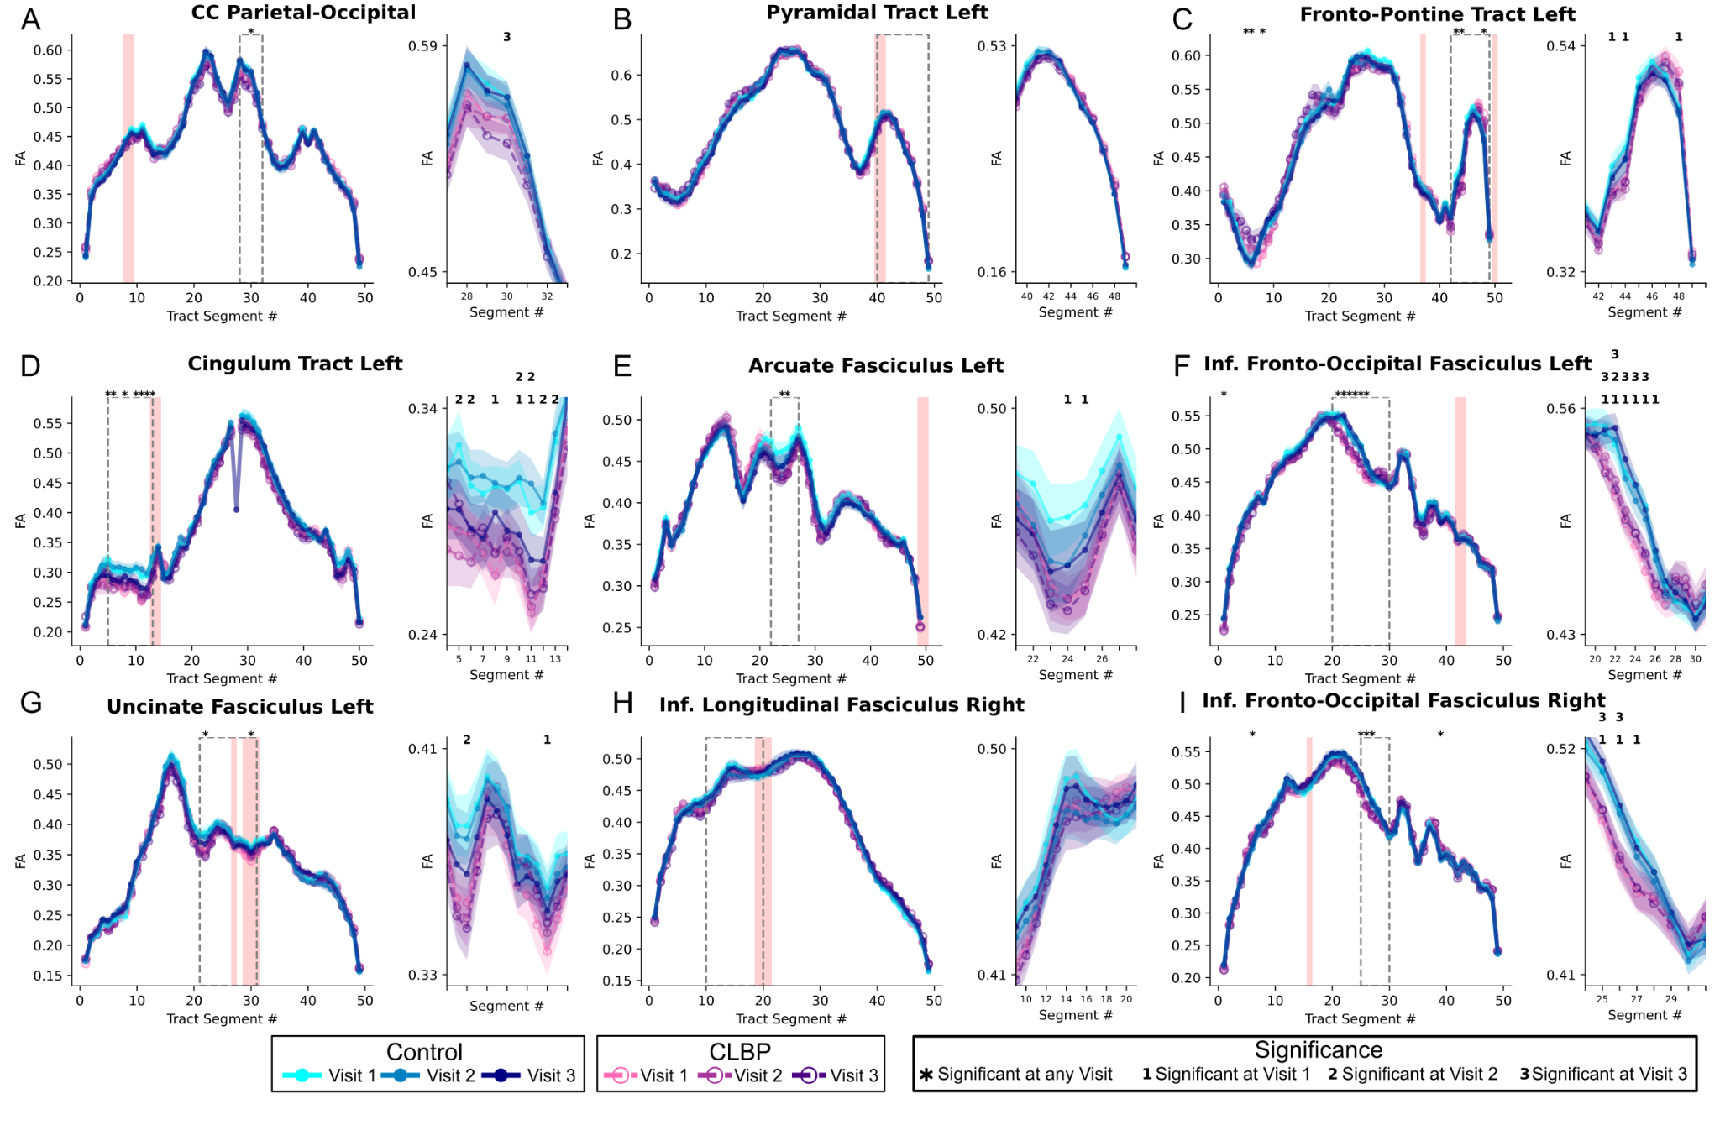
Figure S4. Tractometry profiles of fractional anisotropy for 9 white matter tracts that overlapped select regions output from the TBSS repeatability analysis (Clusters: 1, 2, 3, C, D); A) Parietal-occipital portion of the corpus callosum (Cluster 2), B) Left Pyramidal Tract (Cluster 2), C) Left Fronto-Pontine Tract (Clusters: 1, C), D) Cingulum Tract Left (Clusters: 3) E) Arcuate Fasciculus Left (Cluster C), F) Inferior Fronto-Occipital Fasciculus Left (Cluster C), G) Uncinate Fasciculus Left (Cluster C), H) Inferior Longitudinal Fasciculus Right (Cluster D), I) Inferior Fronto-Occipitial Fasciculus Right (Cluster D). Average fractional anisotropy values are shown for 50 tract segments for controls (cyan to dark blue) and CLBP (pink to dark purple) with zoomed regions depicted in subplots (e.g. dotted grey boxes). For each group and visit standard deviations are displayed with transparency in the associated color. Segments that overlap clusters identified in the proposed TBSS repeatability analysis are highlighted (light red). Regions with a statistically significant difference (two sample t-test, p < 0.05, uncorrected) for at least one of three visits are identified (*), and in the zoomed plots the specific visit with a group difference is identified with a number indicating which visit showed the significant difference.

