Supplementary Material

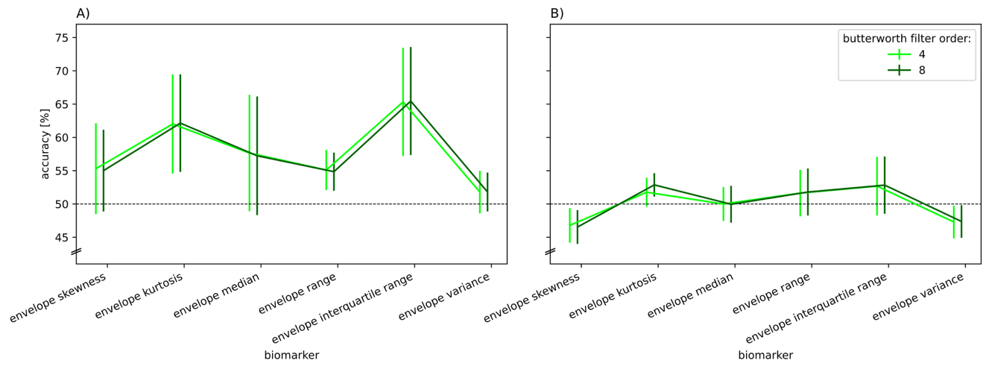
Figure S1. Interaction effects of Butterworth filter order x biomarker on classification performance (balanced accuracy) for A) D1 and B) D2 only for affected envelope biomarkers. Values are averaged across factors for each fold. Error bars depict standard deviations across folds. Abbreviations: D1/2 = dataset 1/2.

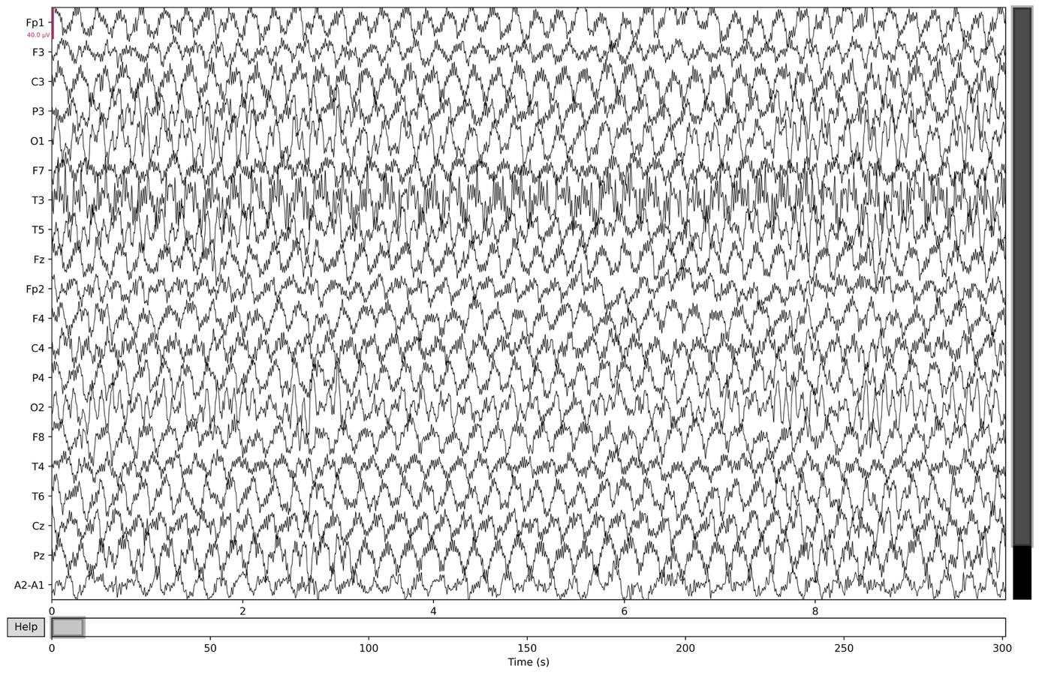
Figure S2. Example of sinusoidal artifacts in D1, 10 s window.

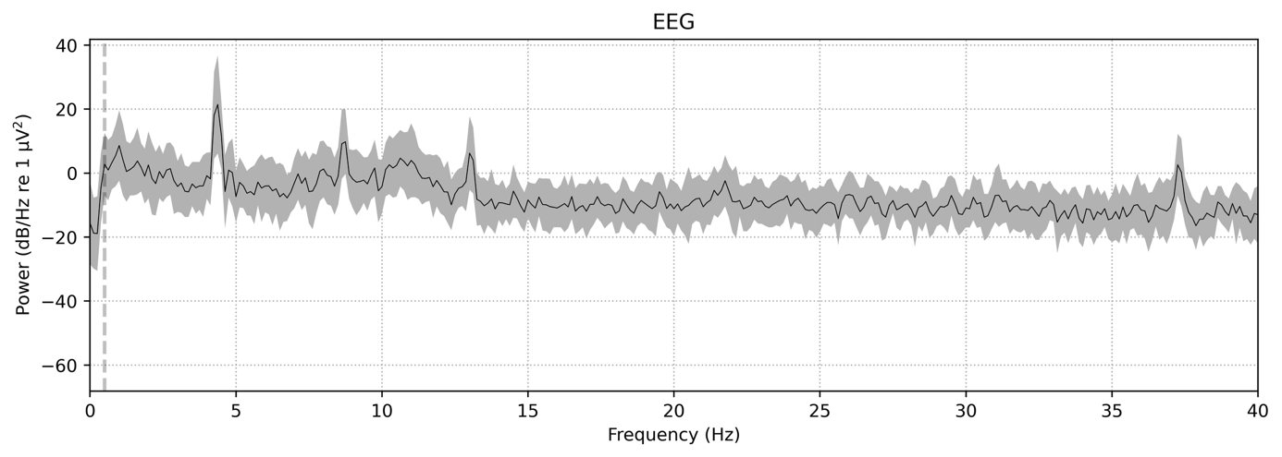
Figure S3. Frequency spectrum corresponding to the window in Figure S2, averaged across all channels.

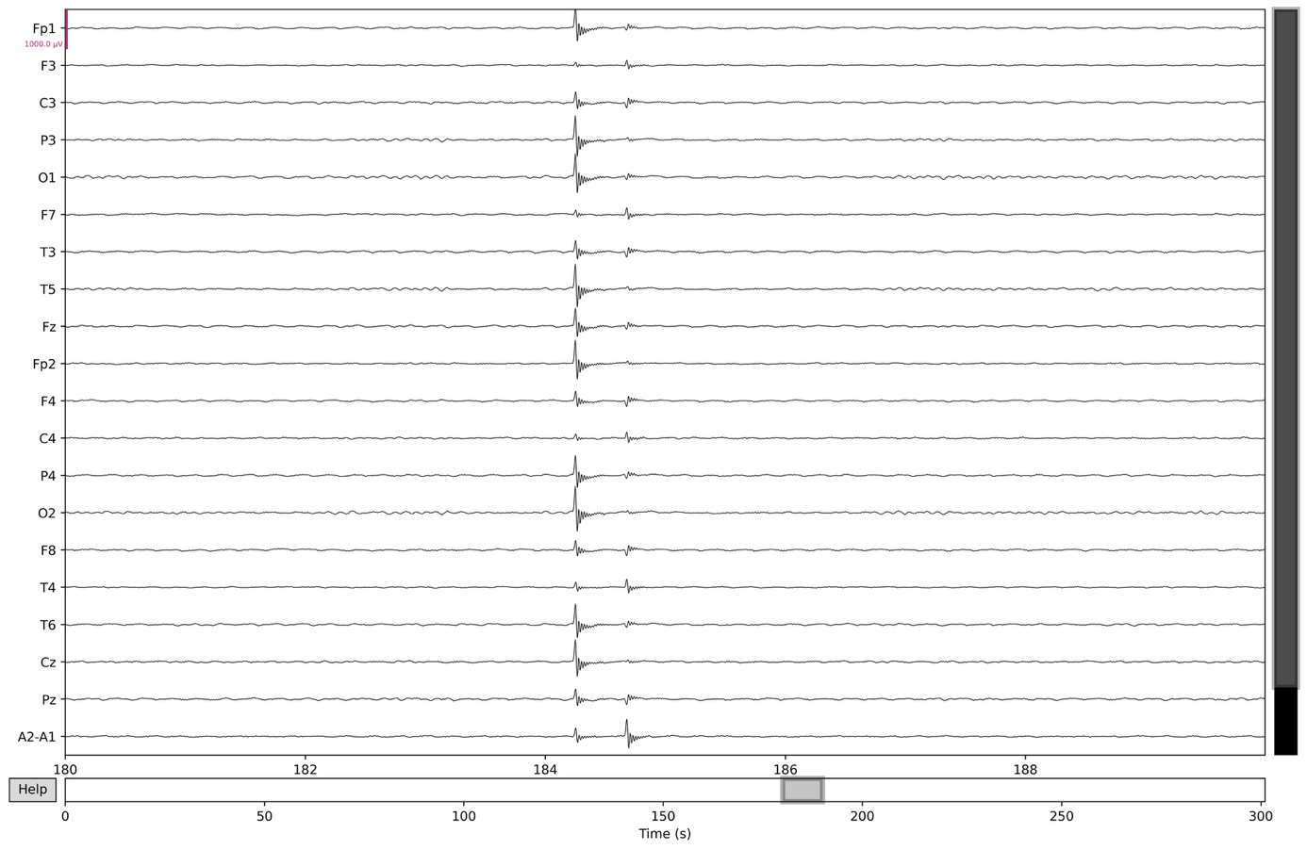
Figure S4. Example of spike artifacts in D1, 10 s window. Note that the scaling of the y-axis is 25x larger than the scaling of Figure S2.

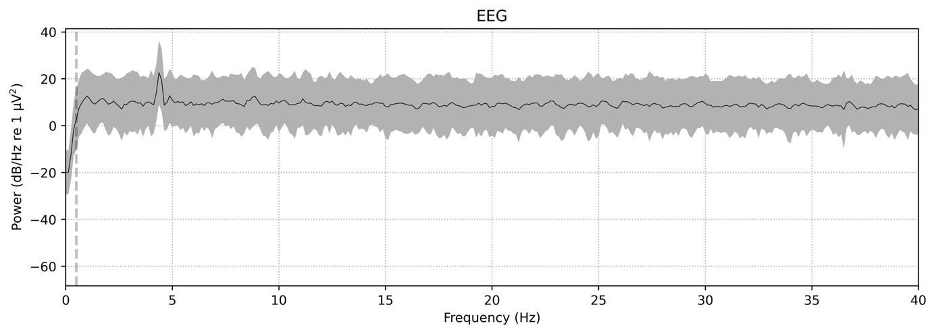
Figure S5. Frequency spectrum corresponding to the window in Figure S4, averaged across all channels.

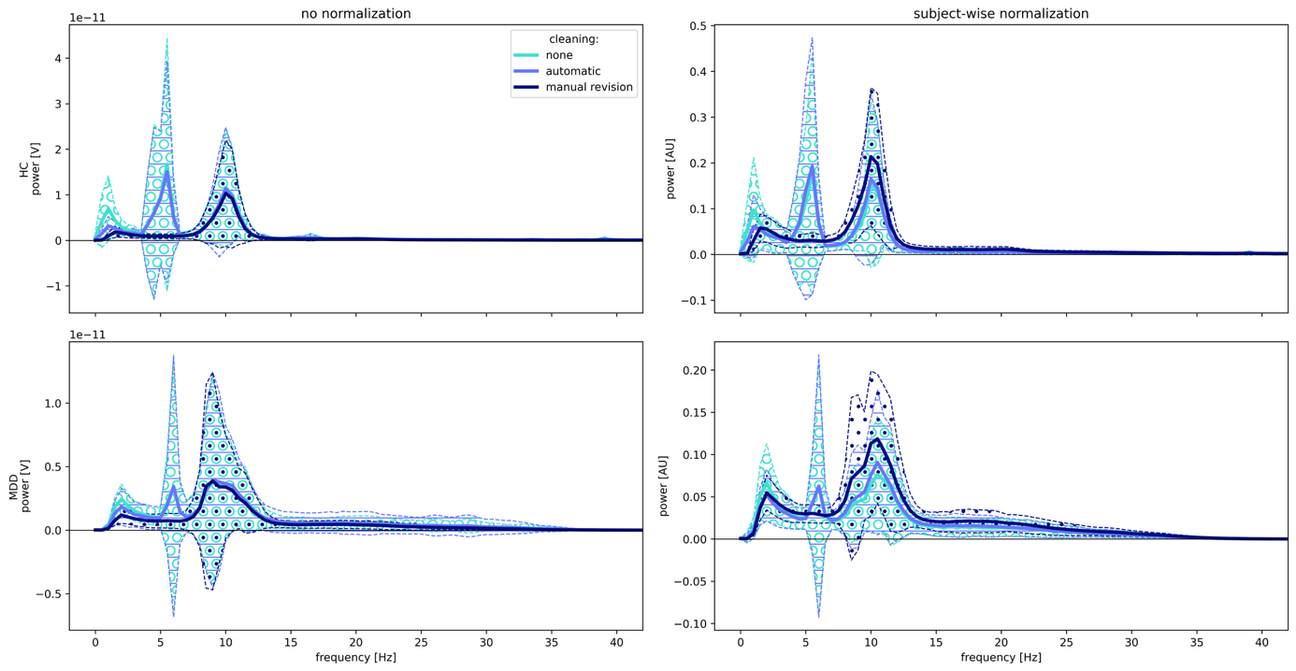
Figure S6. Frequency spectrums of subjects from D1 (HC, n = 23; MDD, n = 25) with three artifact removal methods applied (colored lines) for no normalization (left panels) and subject-wise normalization (right panels). Note the different scaling of the y-axis in the four panels.

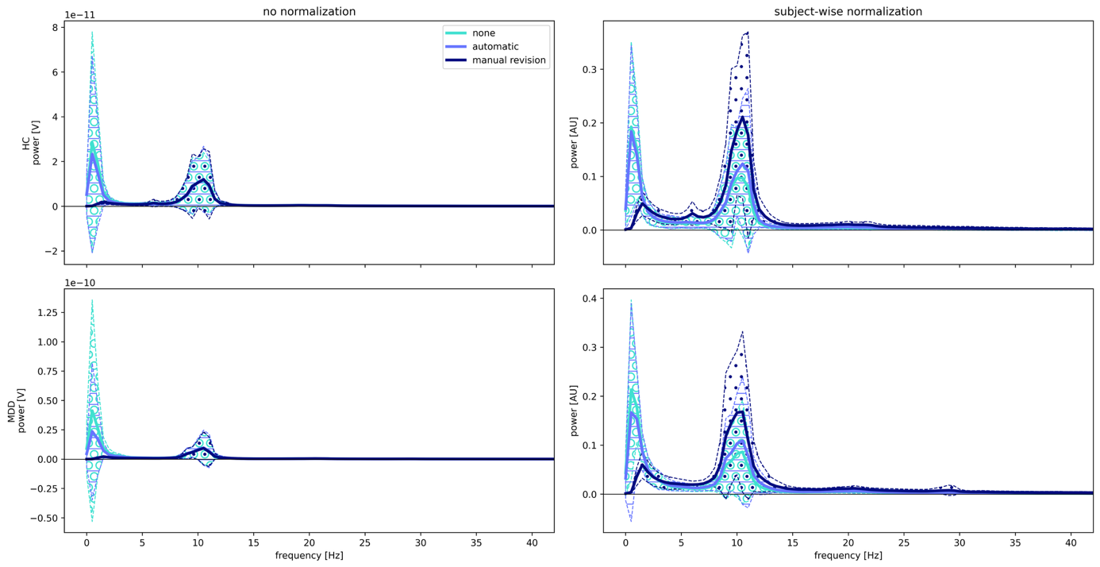
Figure S7. Frequency spectrums of participants from D2 (HC, n = 14; MDD, n = 18) with three artifact removal methods applied (colored lines) for no normalization (left panels) and participant-wise normalization (right panels). Note the different scaling of the y-axis in the four panels.

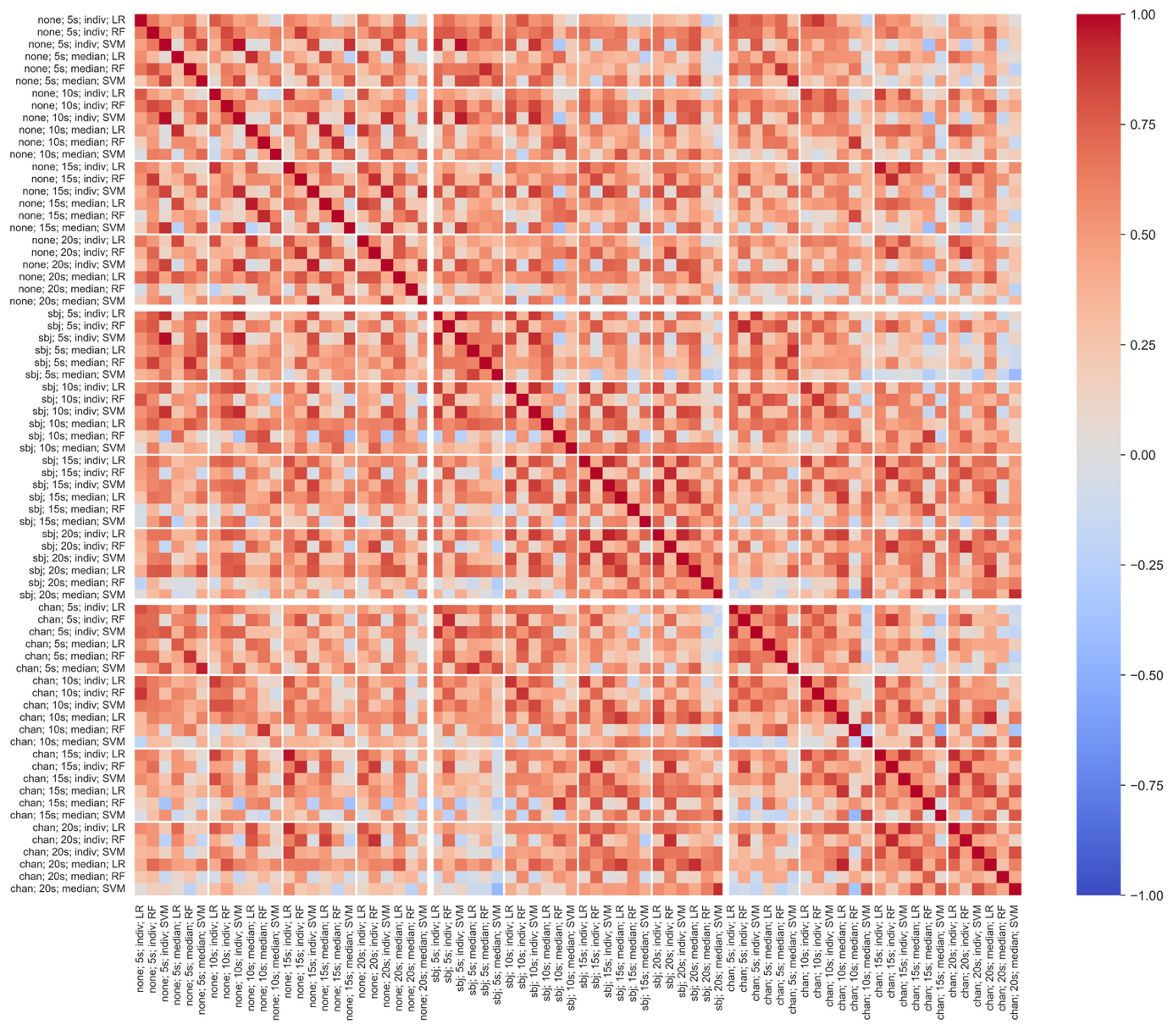
Figure S8. Correlation of classification performance (balanced accuracy) of paths in D2 with Butterworth filter order of 8 and manually revised data (n = 72). Path names are constructed as follows: normalization; segment length; aggregation; algorithm. Big squares depict normalization variants; small squares depict various segment lengths. Abbreviations: none = no normalization, sbj = subject-wise normalization, chan = channel-wise normalization, indiv = individual segments, LR = Logistic Regression, RF = Random Forest, SVM = Support Vector Machine.
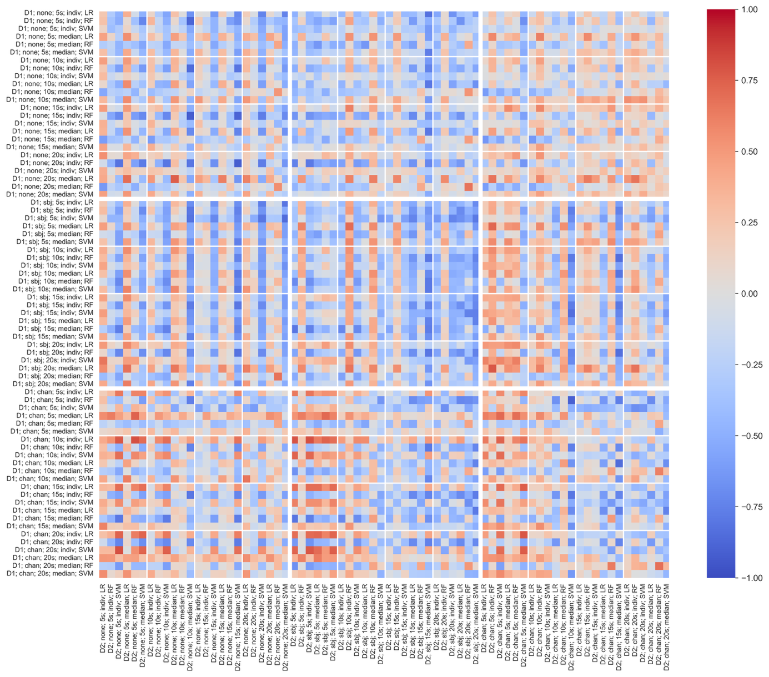
Figure S9. Correlation of classification performance (balanced accuracy) between paths of D1 and D2 with Butterworth filter order of 8 and manually revised data (n = 72). Path names are constructed as follows: dataset; normalization; segment length; aggregation; algorithm. Big squares depict normalization variants; small squares depict various segment lengths. Abbreviations: D1/2 = dataset 1/2, none = no normalization, sbj = subject-wise normalization, chan = channel-wise normalization, indiv = individual segments, LR = Logistic Regression, RF = Random Forest, SVM = Support Vector Machine.

