Supplemental Material
Supplement A. Bland-Altman plots by structure
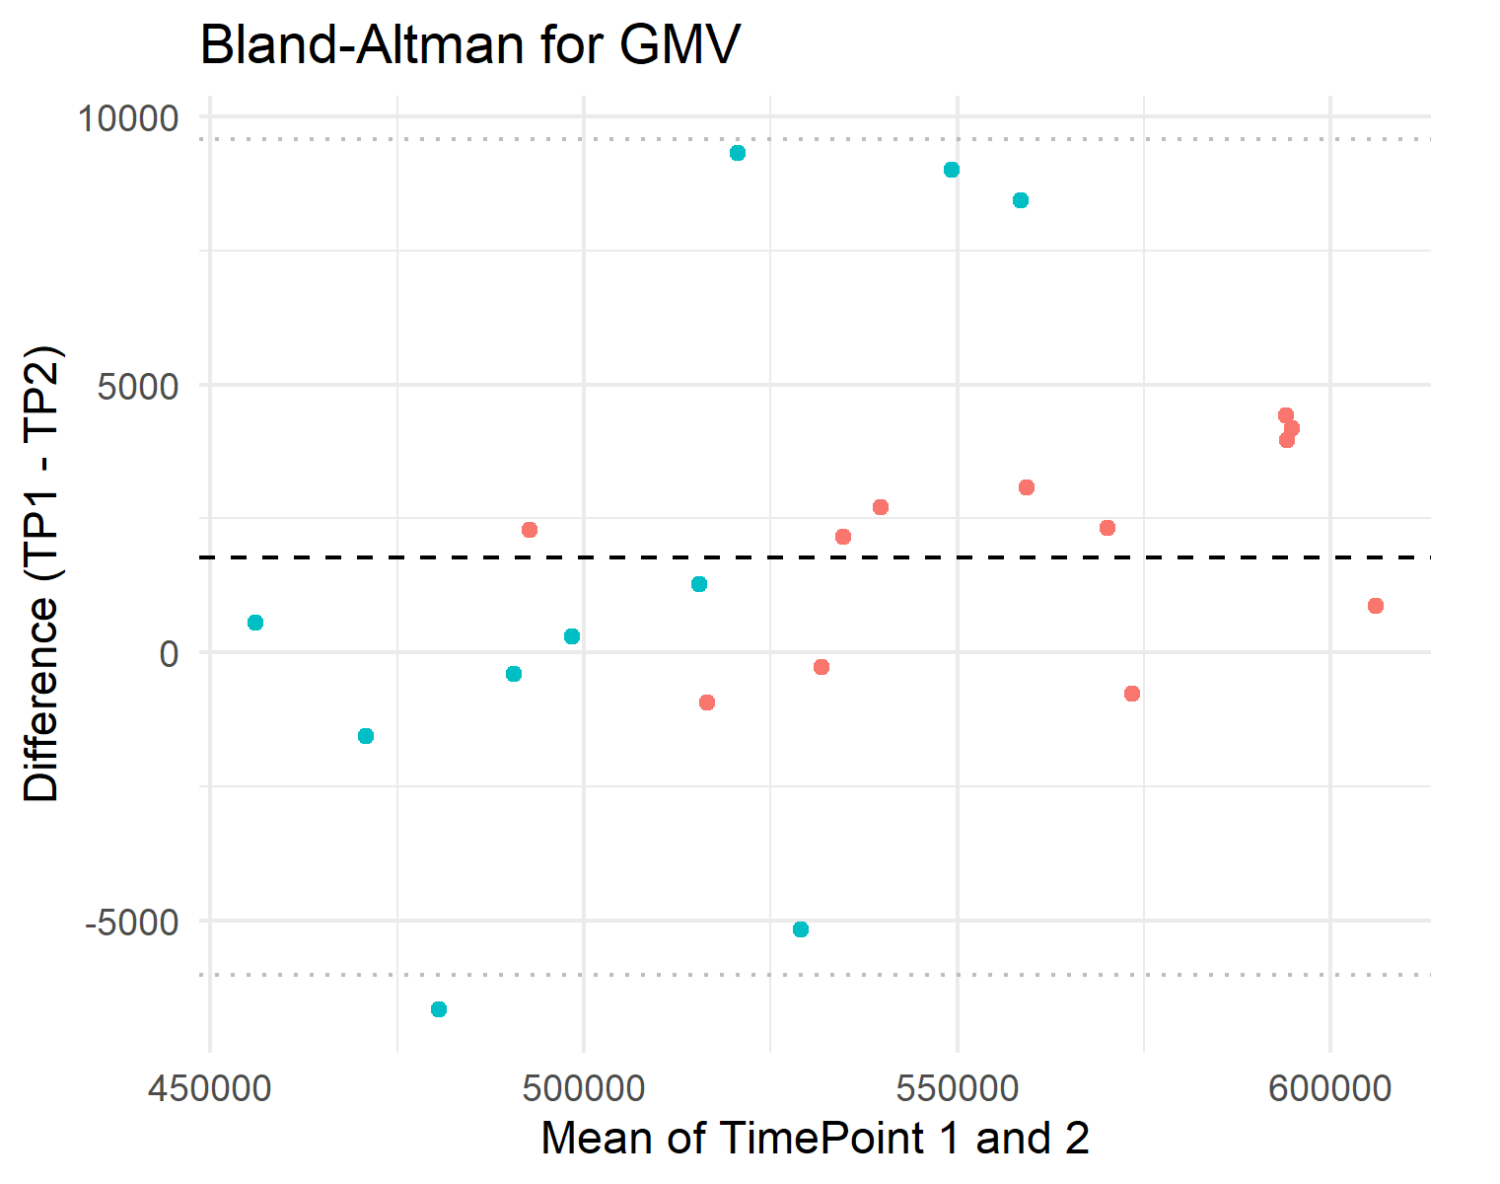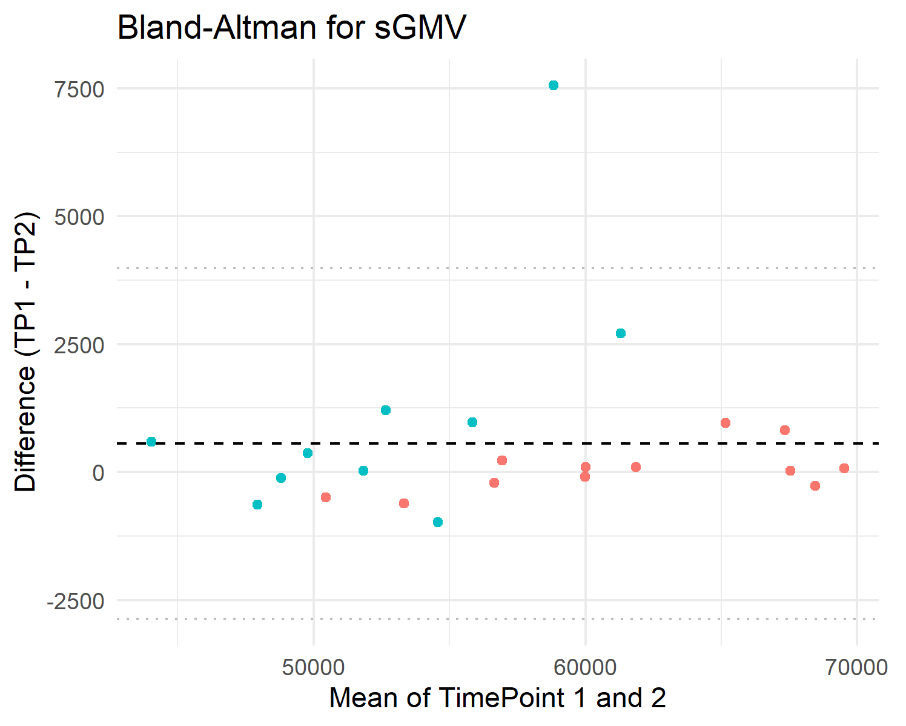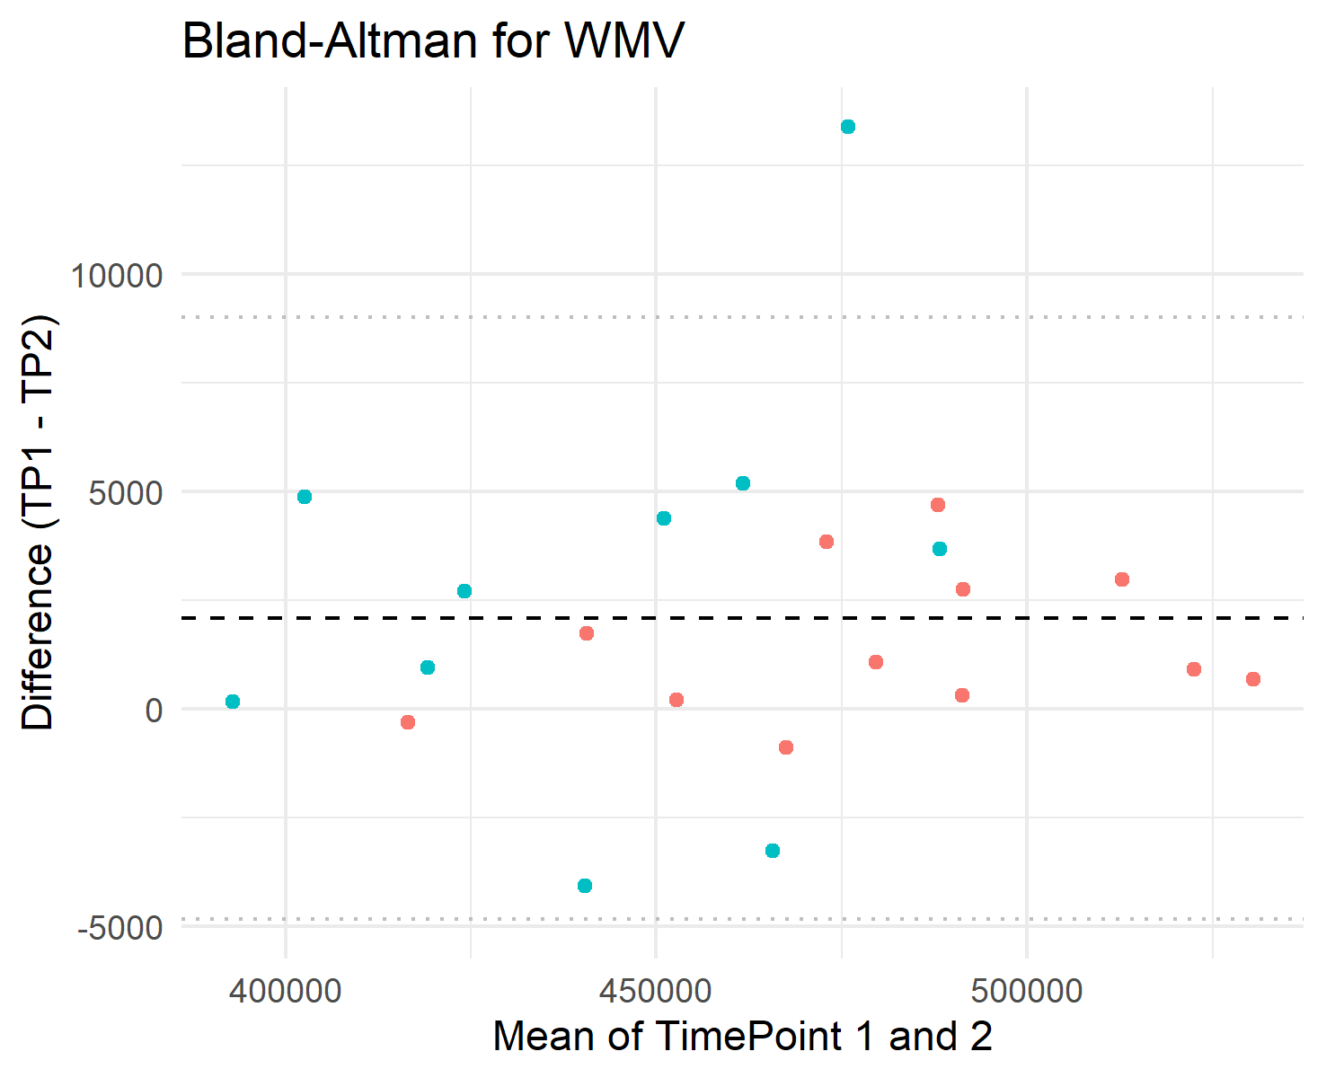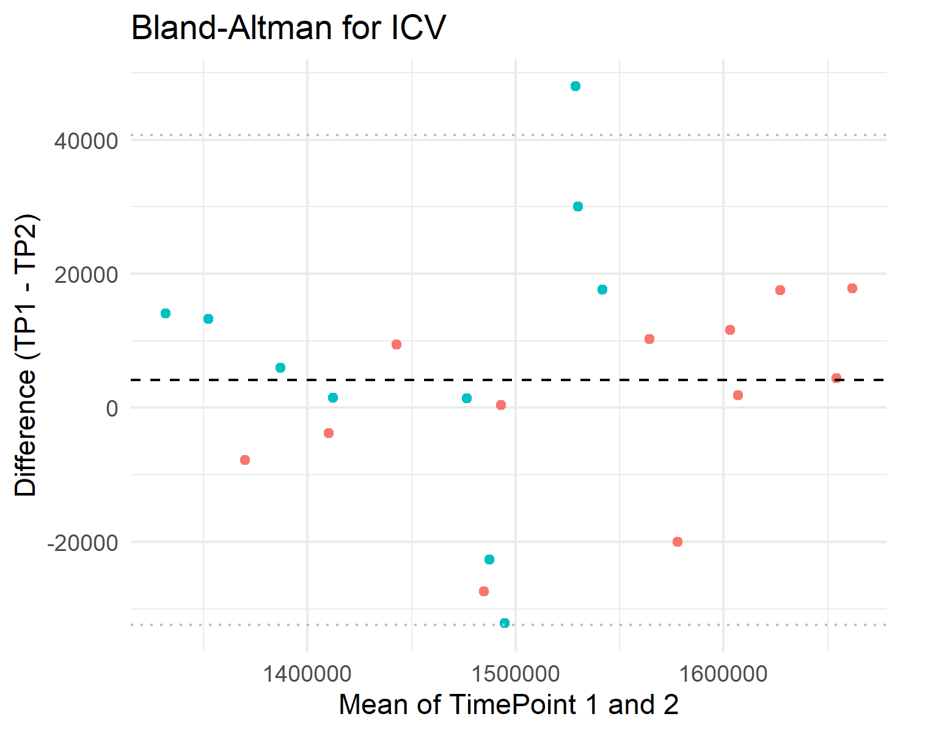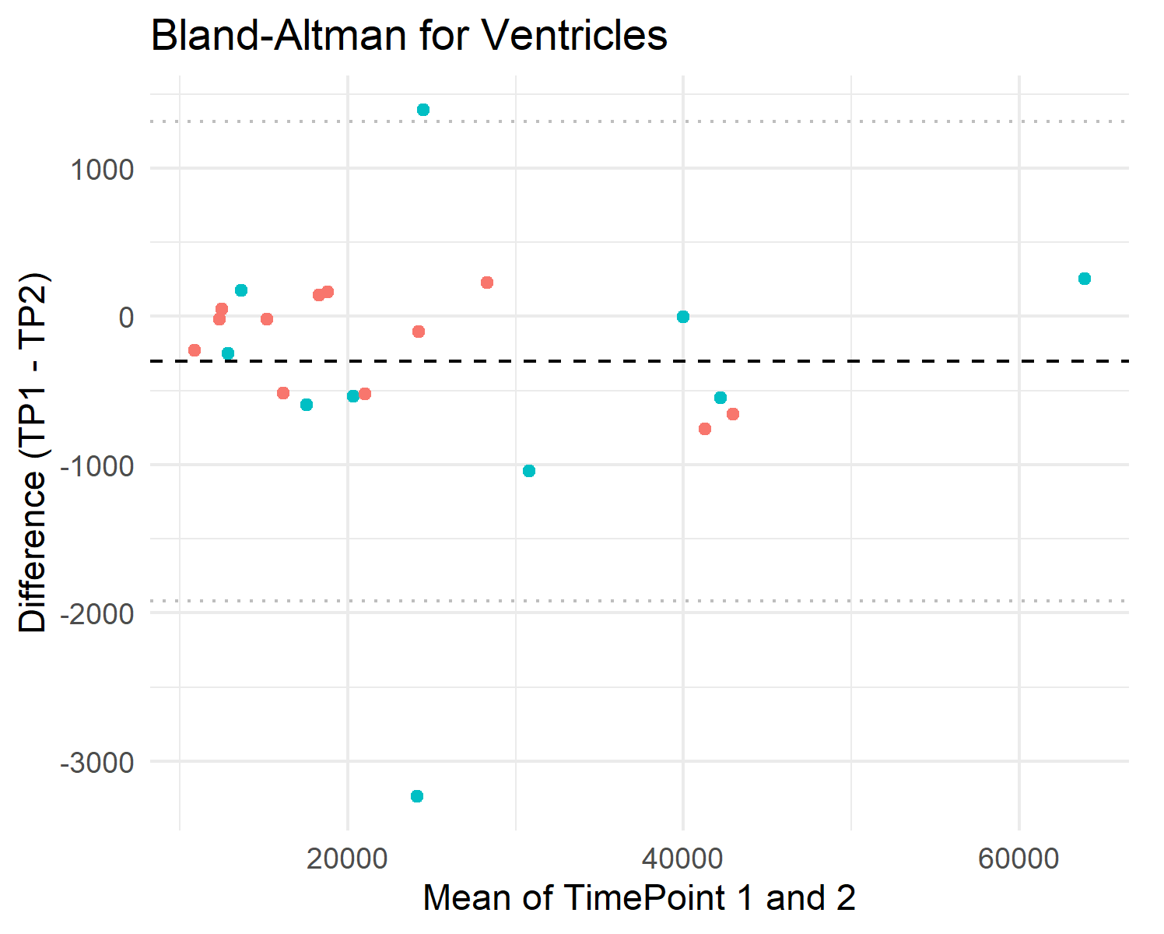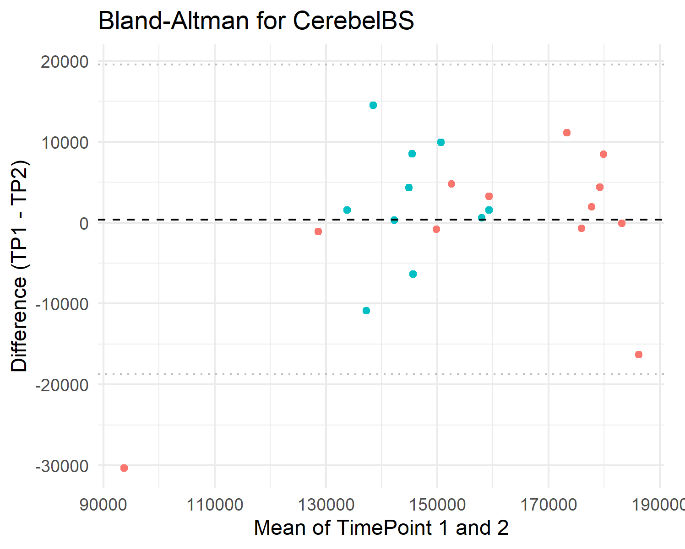

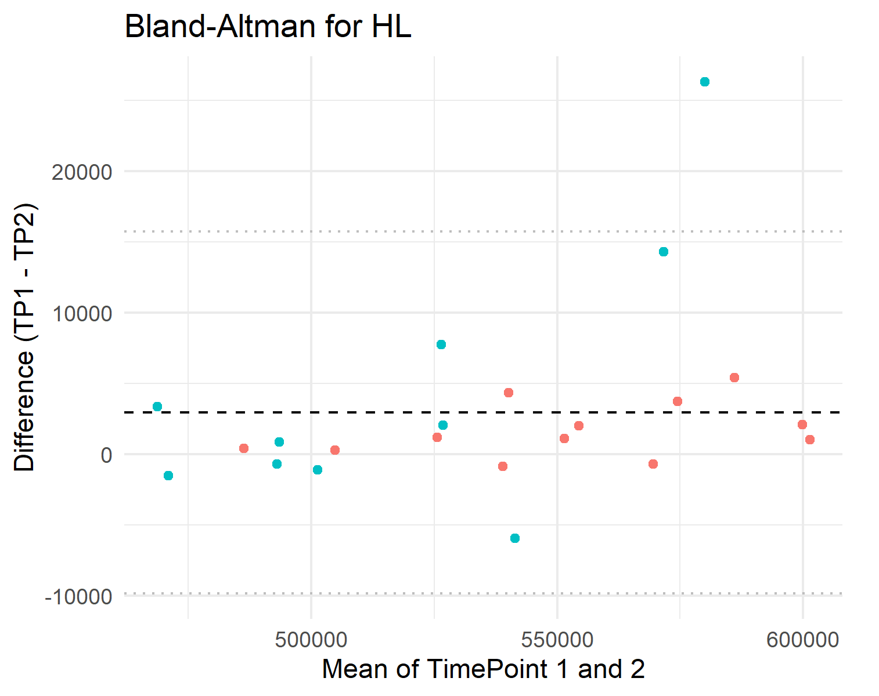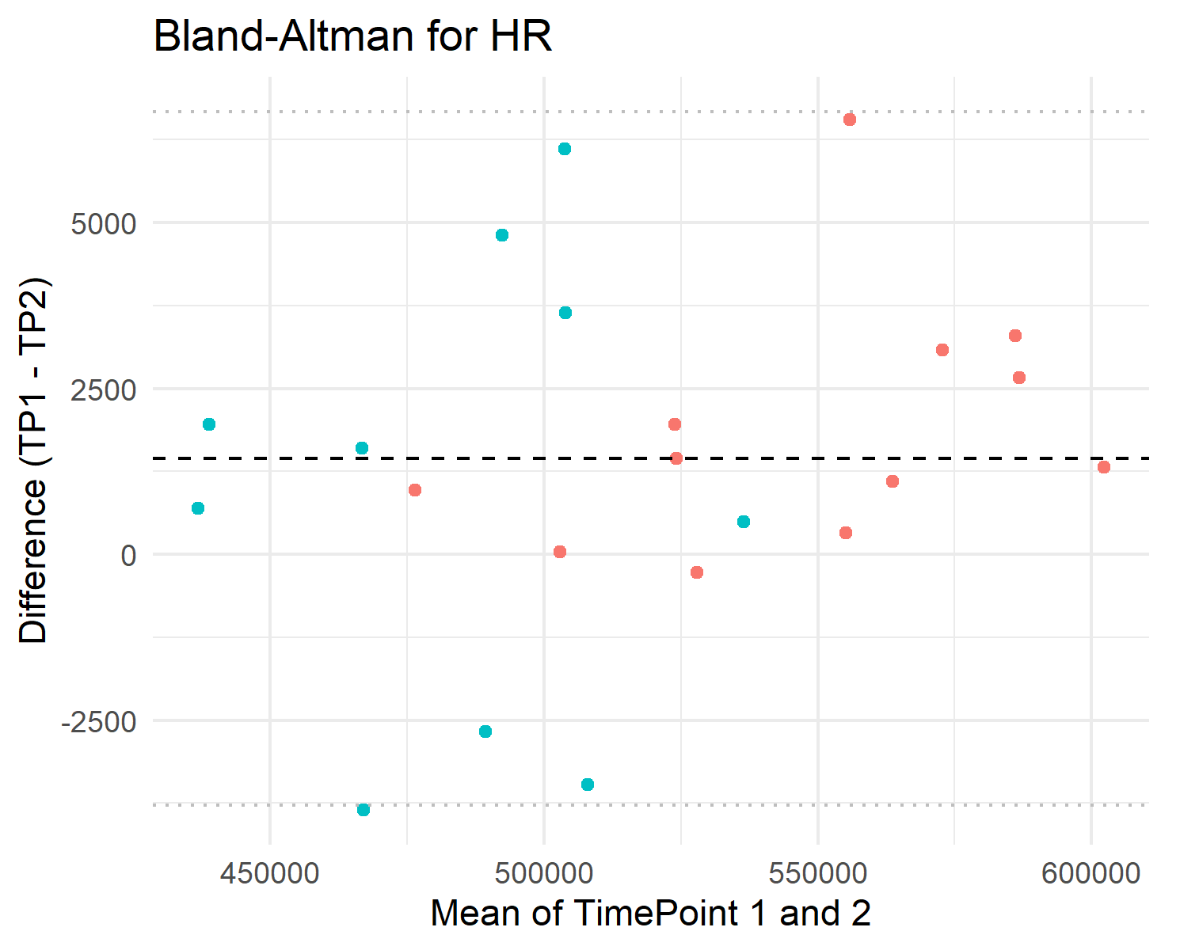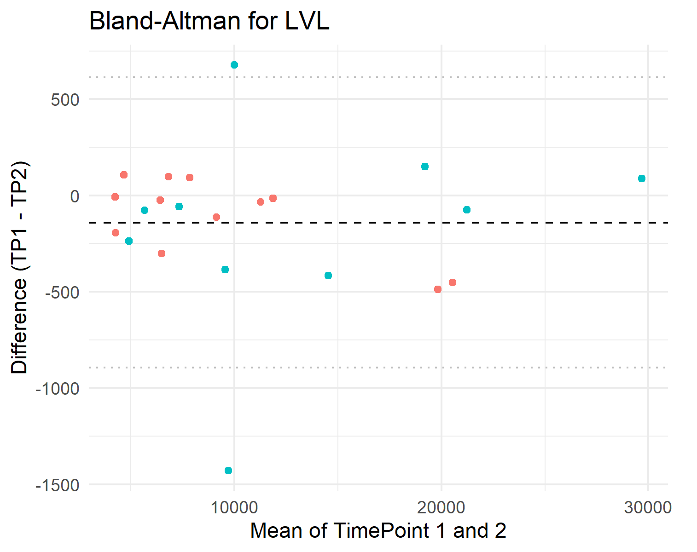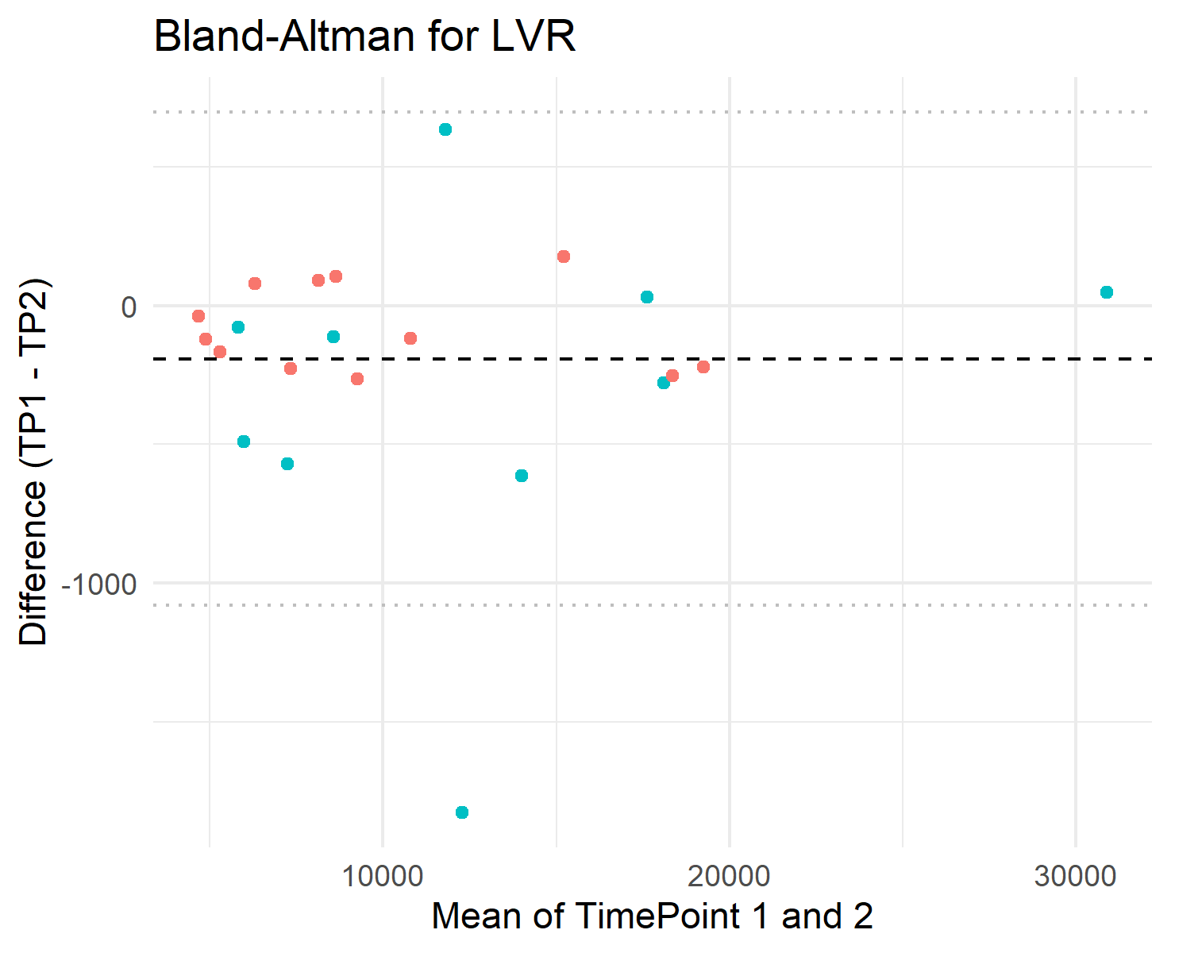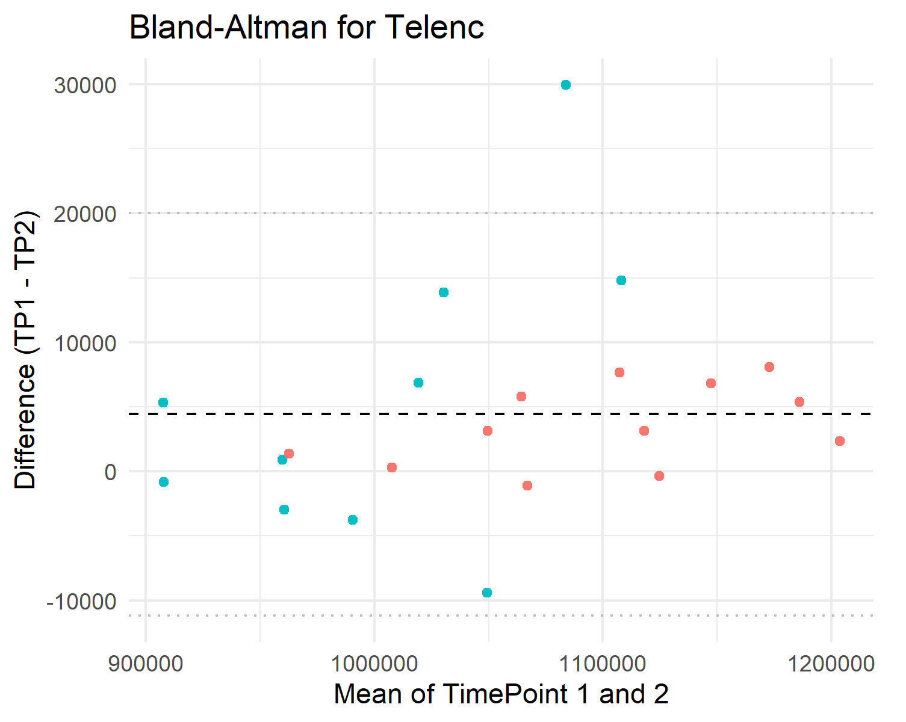
Supplement B. Version Quality Control metrics

Modality | SNR v8 | SNR v9 | CNR v8 | CNR v9
DWI | 2.61 ± 0.83 | 4.71 ± 1.16 | 3.11e+08 ± 1.35e+08 | 3.78e+08 ± 1.81e+08
FLAIR | 3.00 ± 0.53 | 6.23 ± 1.61 | 2.27e+08 ± 1.05e+08 | 3.87e+08 ± 1.34e+08
T1 | 2.86 ± 0.67 | 6.26 ± 1.21 | 2.34e+08 ± 1.12e+08 | 2.89e+08 ± 1.24e+08
T2 | 3.80 ± 0.48 | 5.44 ± 1.14 | 2.99e+08 ± 1.06e+08 | 3.43e+08 ± 1.52e+08
SNR: signal-to-noise ratio, CNR: contrast-to-noise ratio. Metrics were calculated with RadQy GitHub - viswanath-lab/RadQy: RadQy is a quality assurance and checking tool for quantitative assessment of magnetic resonance imaging (MRI) and computed tomography (CT) data.⁵²

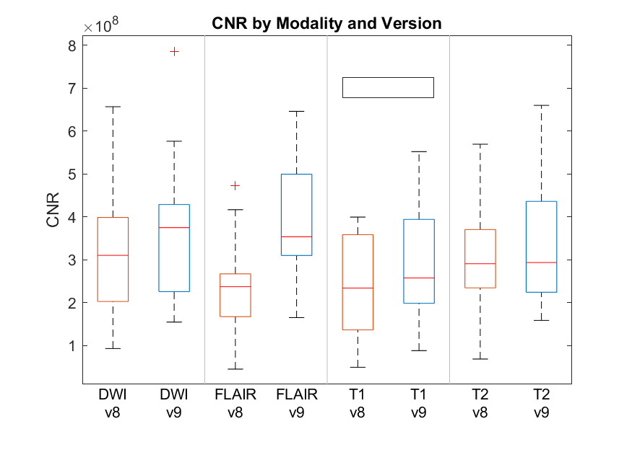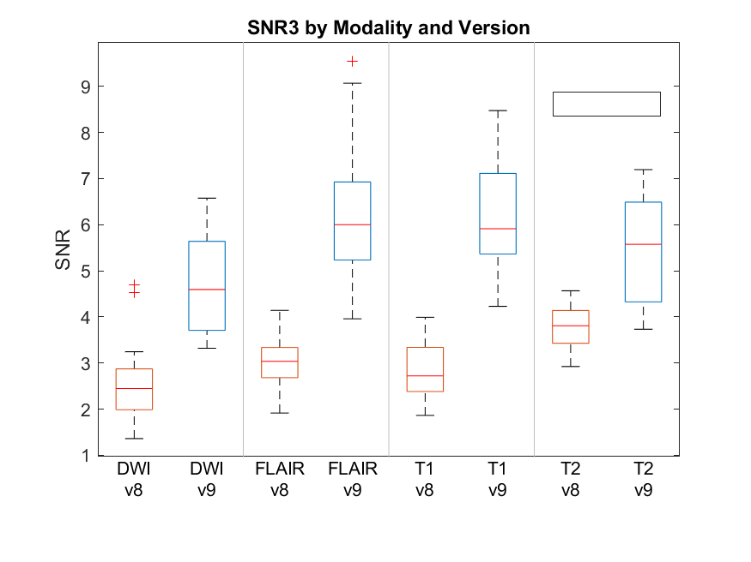

Supplement C. Linear relationship between cortical region size and ICC
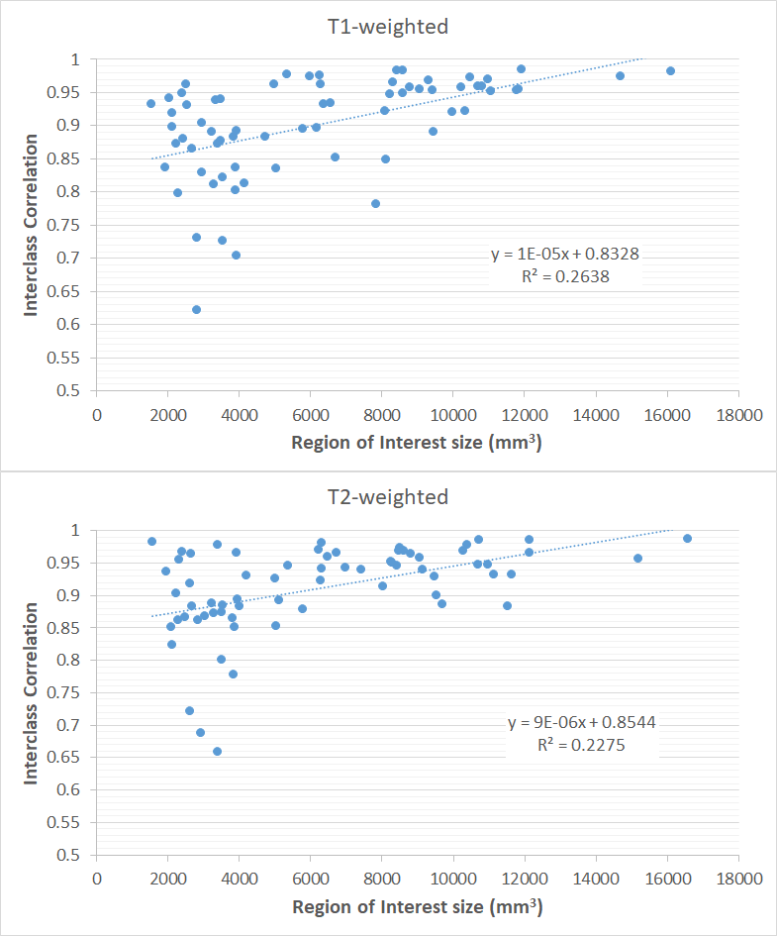

Supplement D. Assessment of software version effects on regional brain volumes
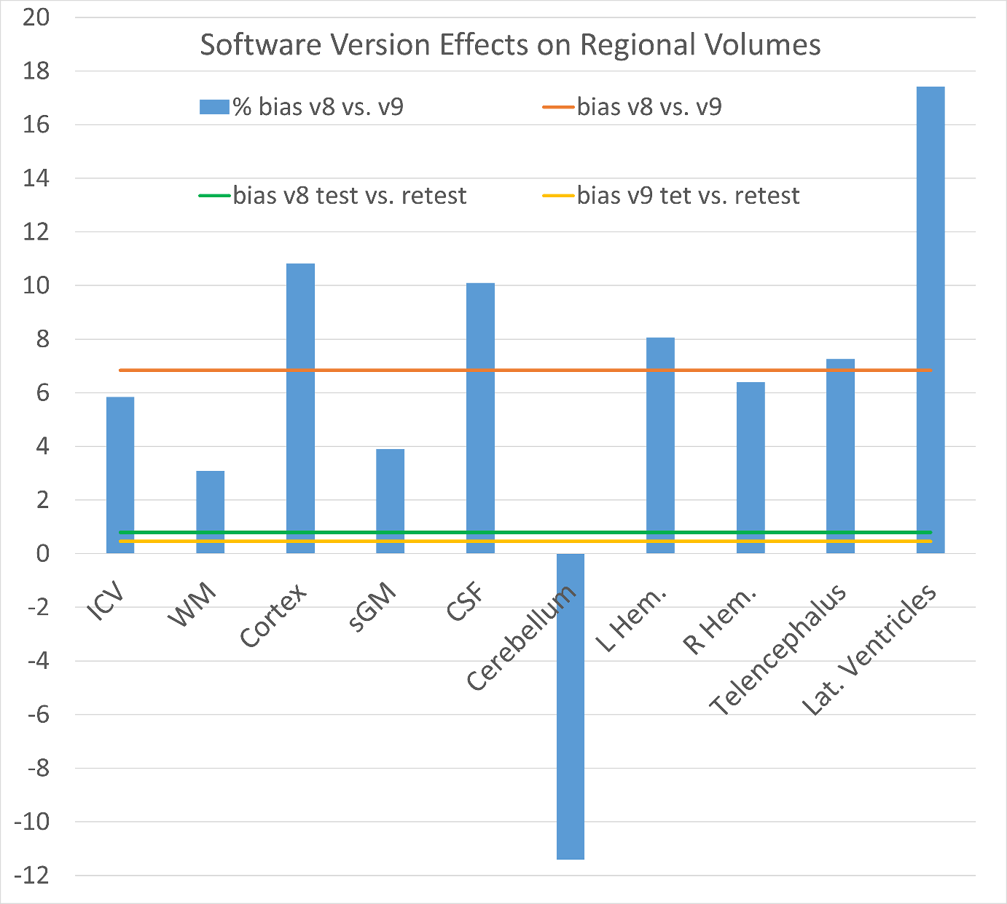
Percent volume differences between pre- (v8) and post- (v9) software upgrade scans are shown for each brain region, computed as the difference between mean post- and pre-upgrade volumes normalized by the pre-upgrade mean. Horizontal lines indicate the mean within-version scan–rescan percent differences estimated from the two repeated acquisitions before (and after) the upgrade, representing expected measurement variability. Post-upgrade volumes showed a consistent positive shift across regions, with pre–post differences exceeding scan–rescan variability in most cases.

Supplement E. Complete table of percentage bias

ID | Percent pre–post shift (bias)
total intracranial | 5.842450174
left cerebral white matter | 3.916856988
left cerebral cortex | 11.60279576
left lateral ventricle | 25.12057232
left inferior lateral ventricle | 24.76000846
left cerebellum white matter | -4.768534943
left cerebellum cortex | -3.406905397
left thalamus | -21.45148343
left caudate | 15.6310199
left putamen | -6.931395885
left pallidum | 9.509897477
3rd ventricle | 12.10681504
4th ventricle | 9.526375639
brain-stem | -2.459654503
left hippocampus | 29.78870172
left amygdala | 24.84364293
csf | 10.09576704
left accumbens area | 13.11243793
left ventral DC | 8.93472665
right cerebral white matter | 2.211720388
right cerebral cortex | 9.97533424
right lateral ventricle | 12.11714844
right inferior lateral ventricle | 23.74885351
right cerebellum white matter | -22.44156037
right cerebellum cortex | -15.05891671
right thalamus | -8.244922037
right caudate | 8.964530675
right putamen | -4.098571478
right pallidum | -10.18157197
right hippocampus | 19.90632023
right amygdala | 1.254635291
right accumbens area | 13.55206943
right ventral DC | 5.039786848
ctx-lh-bankssts | 17.85839169
ctx-lh-caudalanteriorcingulate | 9.631090579
ctx-lh-caudalmiddlefrontal | 8.723977784
ctx-lh-cuneus | 3.938265211
ctx-lh-entorhinal | 11.38695734
ctx-lh-fusiform | 6.316146996
ctx-lh-inferiorparietal | 12.24776273
ctx-lh-inferiortemporal | 19.16877272
ctx-lh-isthmuscingulate | 4.968026512
ctx-lh-lateraloccipital | -0.186658065
ctx-lh-lateralorbitofrontal | 6.395440357
ctx-lh-lingual | -4.702222646
ctx-lh-medialorbitofrontal | 6.878312867
ctx-lh-middletemporal | 14.74176839
ctx-lh-parahippocampal | 5.657384248
ctx-lh-paracentral | 10.25083422
ctx-lh-parsopercularis | 16.49244426
ctx-lh-parsorbitalis | 16.9696702
ctx-lh-parstriangularis | 19.80937988
ctx-lh-pericalcarine | 0.108097258
ctx-lh-postcentral | 18.50869929
ctx-lh-posteriorcingulate | 7.391402377
ctx-lh-precentral | 15.82898561
ctx-lh-precuneus | 8.297563375
ctx-lh-rostralanteriorcingulate | 25.6358274
ctx-lh-rostralmiddlefrontal | 16.27753878
ctx-lh-superiorfrontal | 14.33412808
ctx-lh-superiorparietal | 2.184458159
ctx-lh-superiortemporal | 16.49753387
ctx-lh-supramarginal | 12.63352504
ctx-lh-frontalpole | 13.2423213
ctx-lh-temporalpole | 12.64443333
ctx-lh-transversetemporal | 12.59644803
ctx-lh-insula | 23.57640094
ctx-rh-bankssts | 10.54415882
ctx-rh-caudalanteriorcingulate | 9.935863863
ctx-rh-caudalmiddlefrontal | 1.13979891
ctx-rh-cuneus | 13.99098909
ctx-rh-entorhinal | 6.324621221
ctx-rh-fusiform | 7.142898318
ctx-rh-inferiorparietal | 4.475499882
ctx-rh-inferiortemporal | 5.634125263
ctx-rh-isthmuscingulate | 4.598725817
ctx-rh-lateraloccipital | 13.44383957
ctx-rh-lateralorbitofrontal | 13.24775954
ctx-rh-lingual | 15.64254241
ctx-rh-medialorbitofrontal | 4.758569615
ctx-rh-middletemporal | 3.196951355
ctx-rh-parahippocampal | 18.47204513
ctx-rh-paracentral | 12.46329043
ctx-rh-parsopercularis | 9.456209597
ctx-rh-parsorbitalis | -0.28781615
ctx-rh-parstriangularis | 3.556827469
ctx-rh-pericalcarine | 12.17939685
ctx-rh-postcentral | 11.69315517
ctx-rh-posteriorcingulate | 7.752901238
ctx-rh-precentral | 17.00404439
ctx-rh-precuneus | 5.285766327
ctx-rh-rostralanteriorcingulate | 9.805804757
ctx-rh-rostralmiddlefrontal | 15.68398874
ctx-rh-superiorfrontal | 15.73284309
ctx-rh-superiorparietal | 9.830472239
ctx-rh-superiortemporal | 9.045250067
ctx-rh-supramarginal | 12.01382488
ctx-rh-frontalpole | 5.125633692
ctx-rh-temporalpole | 1.99084688
ctx-rh-transversetemporal | -2.031886717
ctx-rh-insula | 17.5473756

Notes: Median bias = 9.806, Median bias % difference pre-T2 = 4.231, Median bias % difference post-T2 = 2.822.

