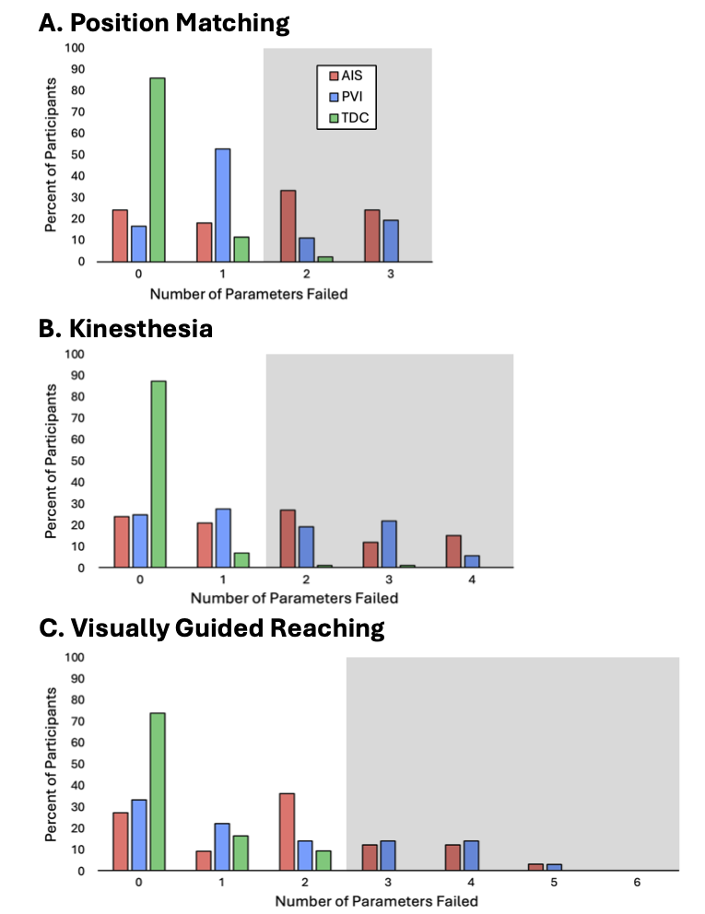
Supplementary Figure S1. Outcome parameter and task failure separated by group.
Number of outcome parameters failed by task and group. Performance outside the 95% normative reference range was defined as parameter ‘failure’ and was established from control data, where grey boxes indicate participants lying outside the normative parameter failure cutoffs for each task (≥ 2 for position matching and kinesthesia, ≥ 3 for visually guided reaching). AIS indicates arterial ischemic stroke, PVI indicates periventricular venous infarction, and TDC indicates typically developing controls.

