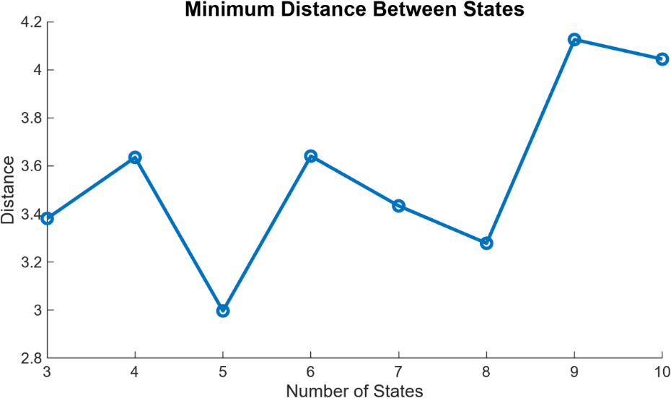
Supplemental Figure 1: Selection of the number of HSMM states. The minimum distance between estimated state covariance matrices is shown as a function of the number of states (3–10).

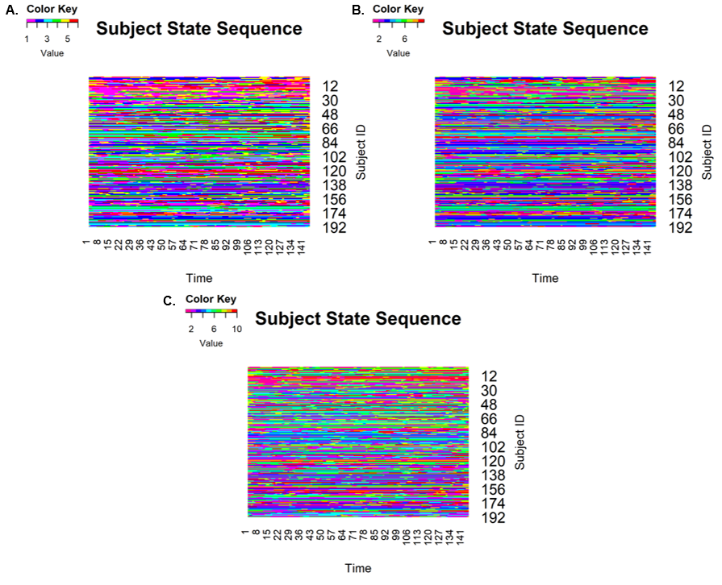
Supplemental Figure 2: Subject-level state sequences for representative HSMM solutions. Rows represent participants and columns represent time points. Colors indicate inferred latent states. Shown are the (A) 6-state, (B) 9-state, and (C) 10-state solutions used to evaluate model complexity and state interpretability.

